Assignment 1: Debugging Transformer Models with PyCharm and WSL

# GitHub Repository:

https://github.com/aya2500/-Assignment_1

# Environment Setup

PyCharm was configured to use WSL as the Python interpreter. Transformer code was executed and debugged successfully inside PyCharm. The debugger was used instead of print statements, as required.

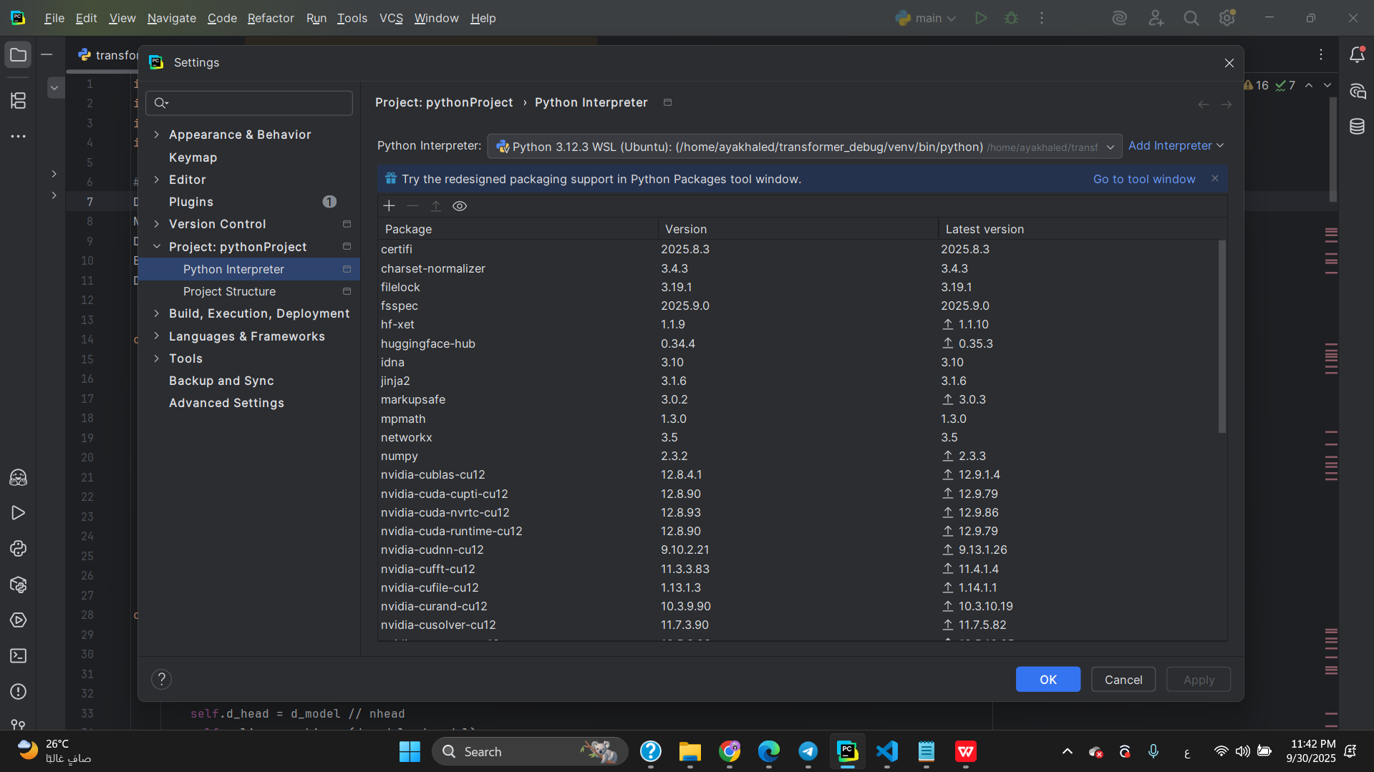

# Input & Target Selection

Domain: Literature

Input sequence (5 tokens): "the poet writes beautiful verses"

Target sequence (5 tokens): "words touch the human soul"

Relation: This pair is used for next-sequence prediction in the literary domain.

## Snapshot #1: Raw input tokens (IDs)

Shape: (1, 5)

Sample values: [[511, 723, 845, 932, 678]]

Explanation: These are the integer IDs representing the input sequence. Each number corresponds to a token in the vocabulary ("the poet writes beautiful verses").

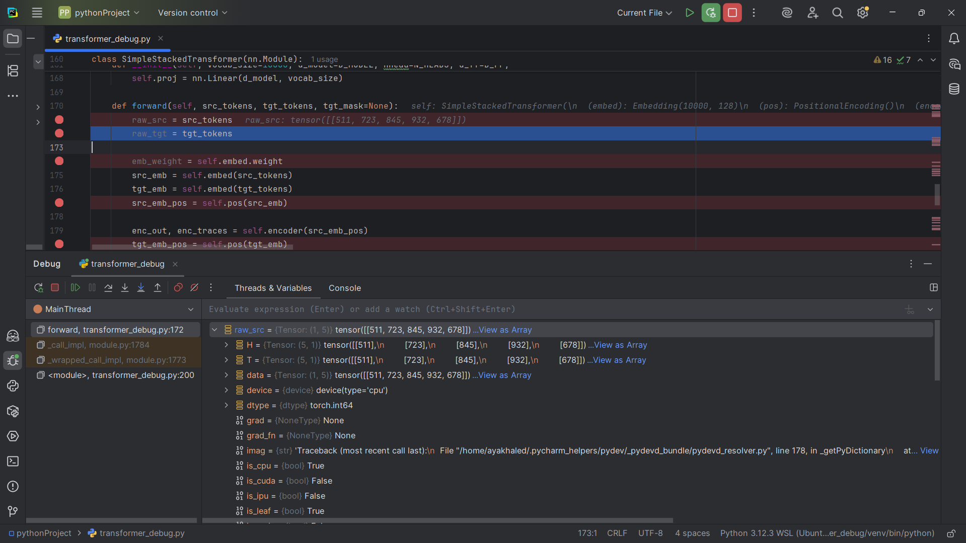

## Snapshot #2: Target tokens (IDs)

Shape: (1, 5)

Sample values: [[812, 459, 511, 390, 275]]

Explanation: These are the integer IDs representing the target sequence. They correspond to the output tokens the model is expected to predict ("words touch the human soul").

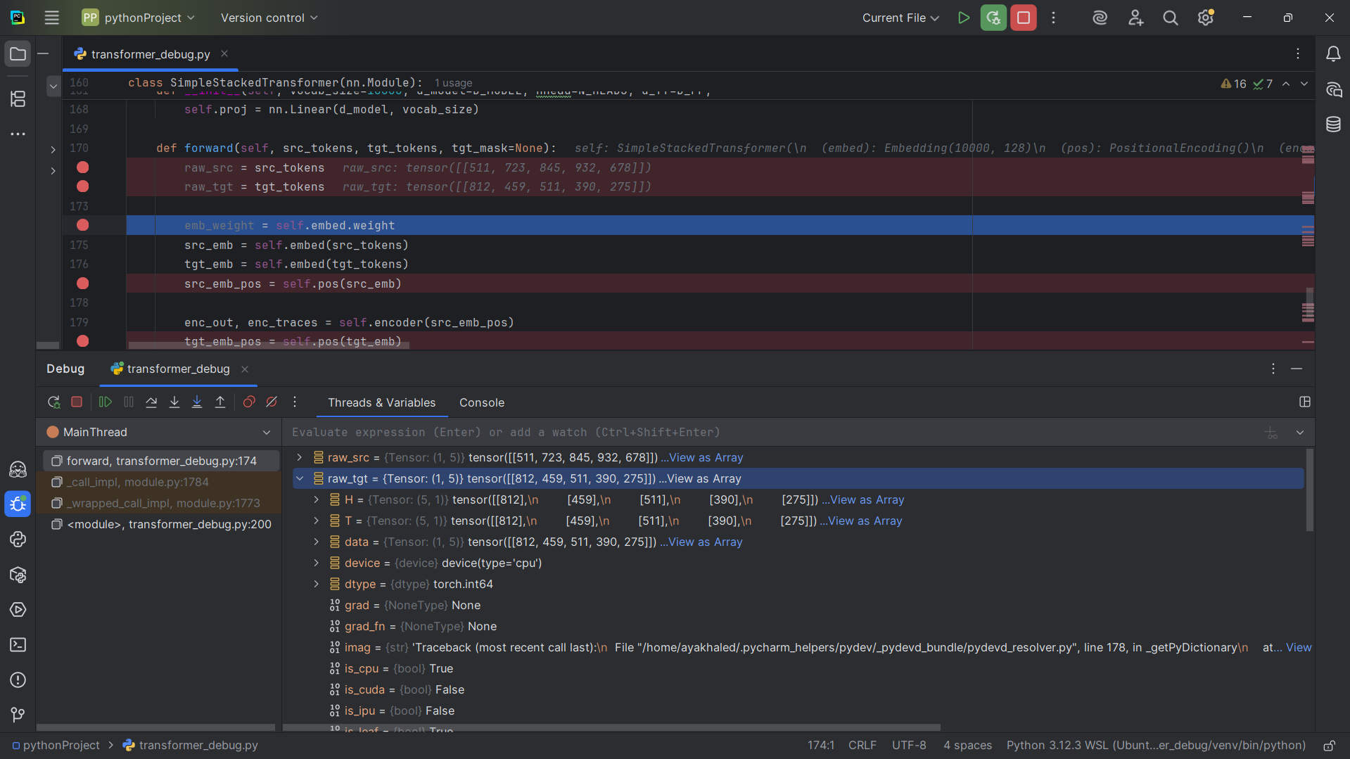

## Snapshot #3: Embedding weight matrix (slice)

Shape: (10000, 128)

Sample values: [[-1.1258, -1.1524, -0.2506, . . .] , [-0.8834, -0.4189, -0.8048, . . . ]]

Explanation: This is the learned lookup table mapping each token ID to a dense vector. Shape is (vocab_size , d_model).

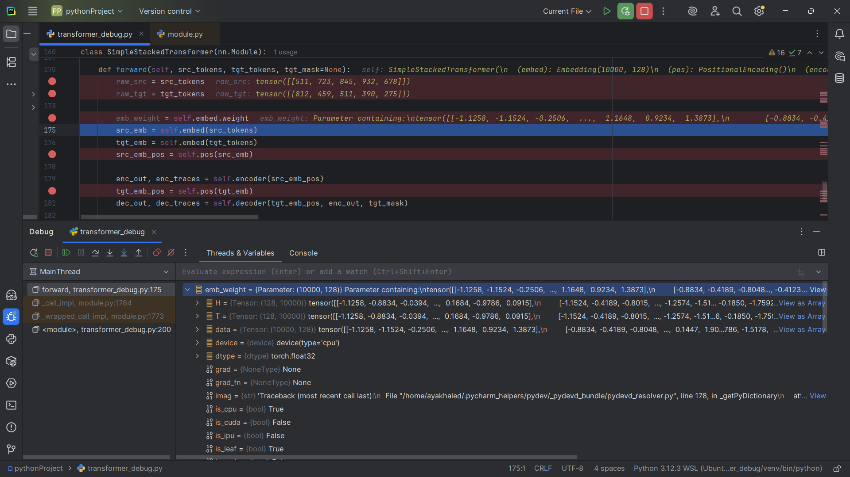

## Snapshot #4: Input embeddings after lookup

Shape: (1, 5, 128)

Sample values: [[-0.0796, 1.2486, 0.2076, . . . ] , [0.4411, -0.6071, 1.2518, . . . ]]

Explanation: Each input token has been mapped to its embedding vector. Shape is (batch, seq_len, d_model).

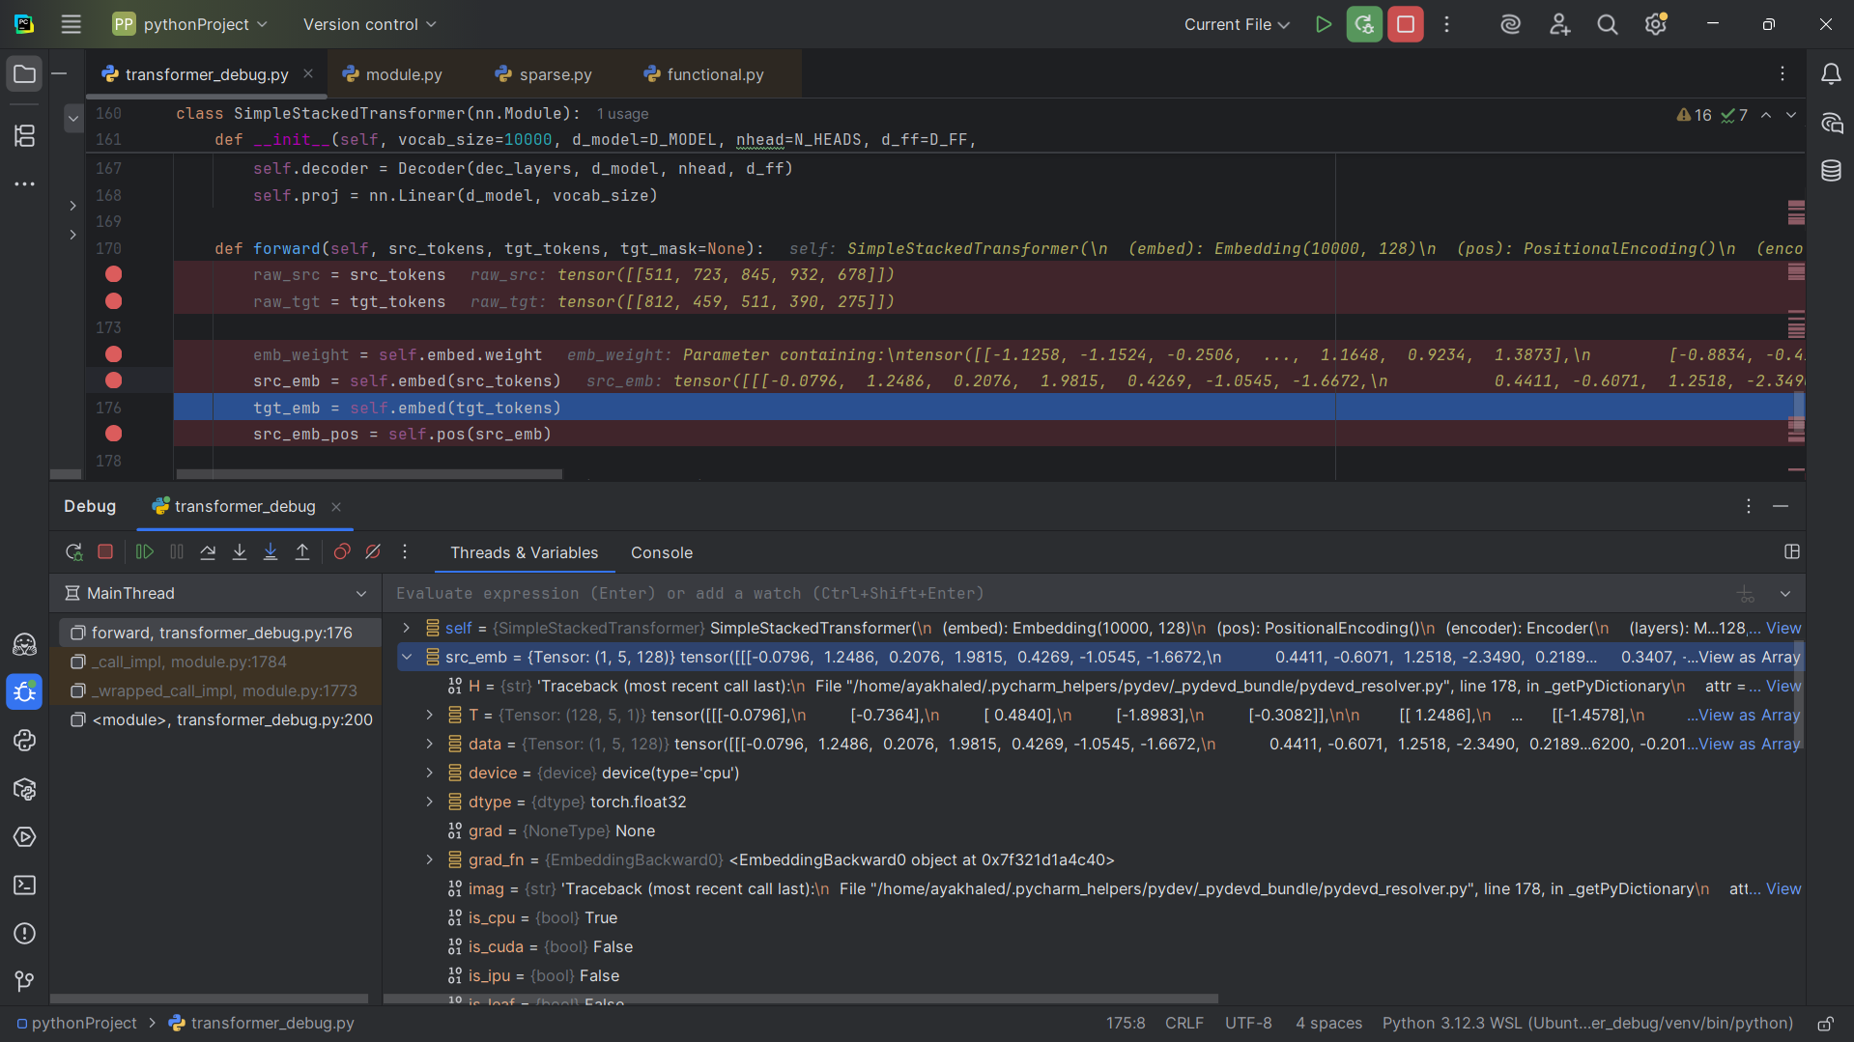

## Snapshot #5: Embeddings after adding positional encoding

Shape: (1, 5, 128)

Sample values: [[-7.9608e-02, 2.2486e+00, 2.0763e-01 , . . . ] , [-5.4507e-02, -1.6672e+00, 1.4411e+00, . . . ]]

Explanation: Positional encoding is added so the model knows the order of tokens. Shape remains (batch, seq_len , d_model). 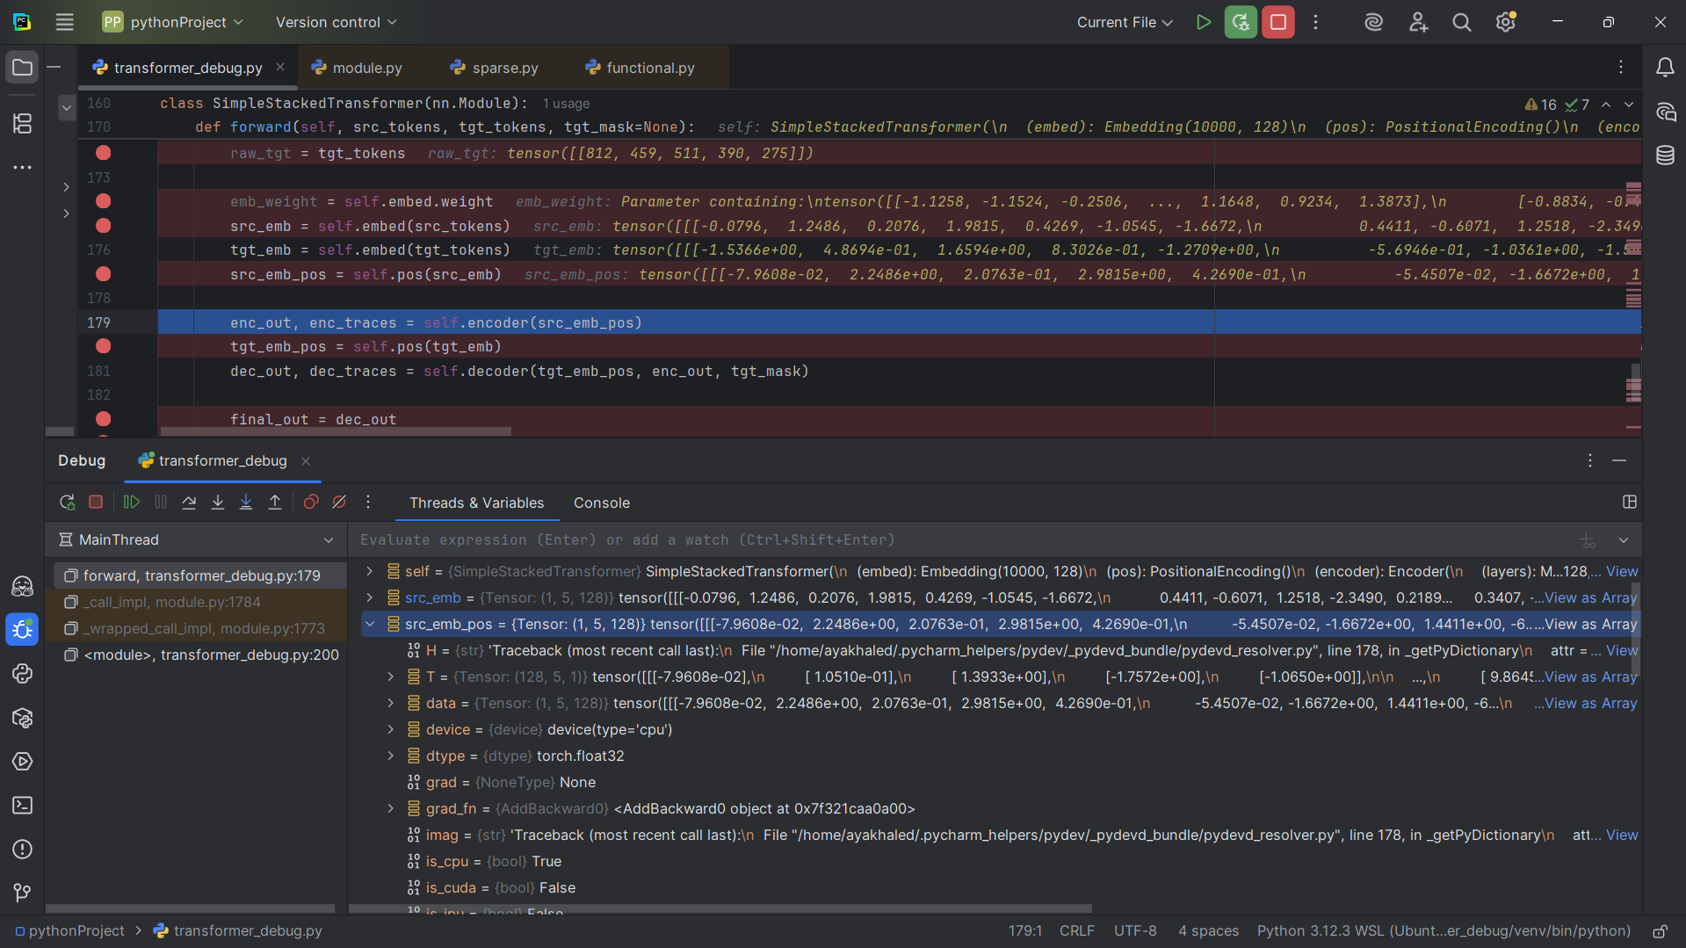

## Snapshot #6: Encoder block input tensor

Shape: (1, 5, 128)

Sample values: [[-7.9608e-02 , 2.2486e+00 , 2.0763e-01, . . .] , [-5.4507e-02 , -1.6672e+00 , 1.4411e+00]]

Explanation: This is the input to the encoder layer, after embedding and positional encoding.

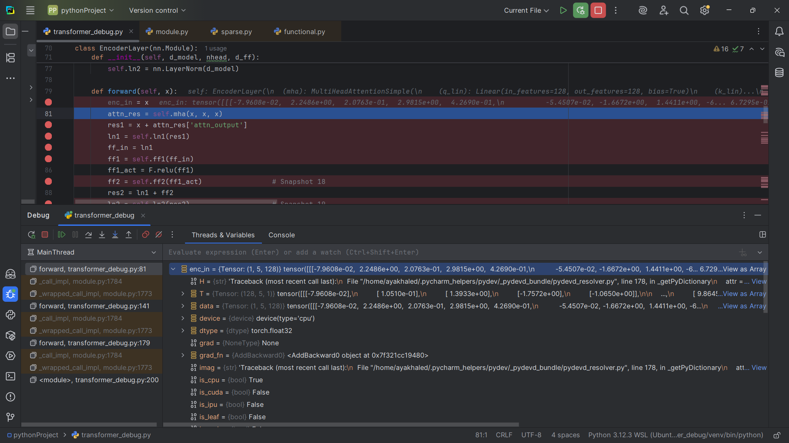

## Snapshot #7: Self-attention queries Q

Shape: (1, 5, 128)

Sample values: [[1.277e-01, -7.761e-01, 5.1287e-01, -1.1407e-02 , . . .] , [-8.001e-02 , 2.0308e-02 , 9.2335e-01 , . . .]]

Explanation: Q is created by linearly projecting the input. Shape matches (batch, seq_len, d_model).

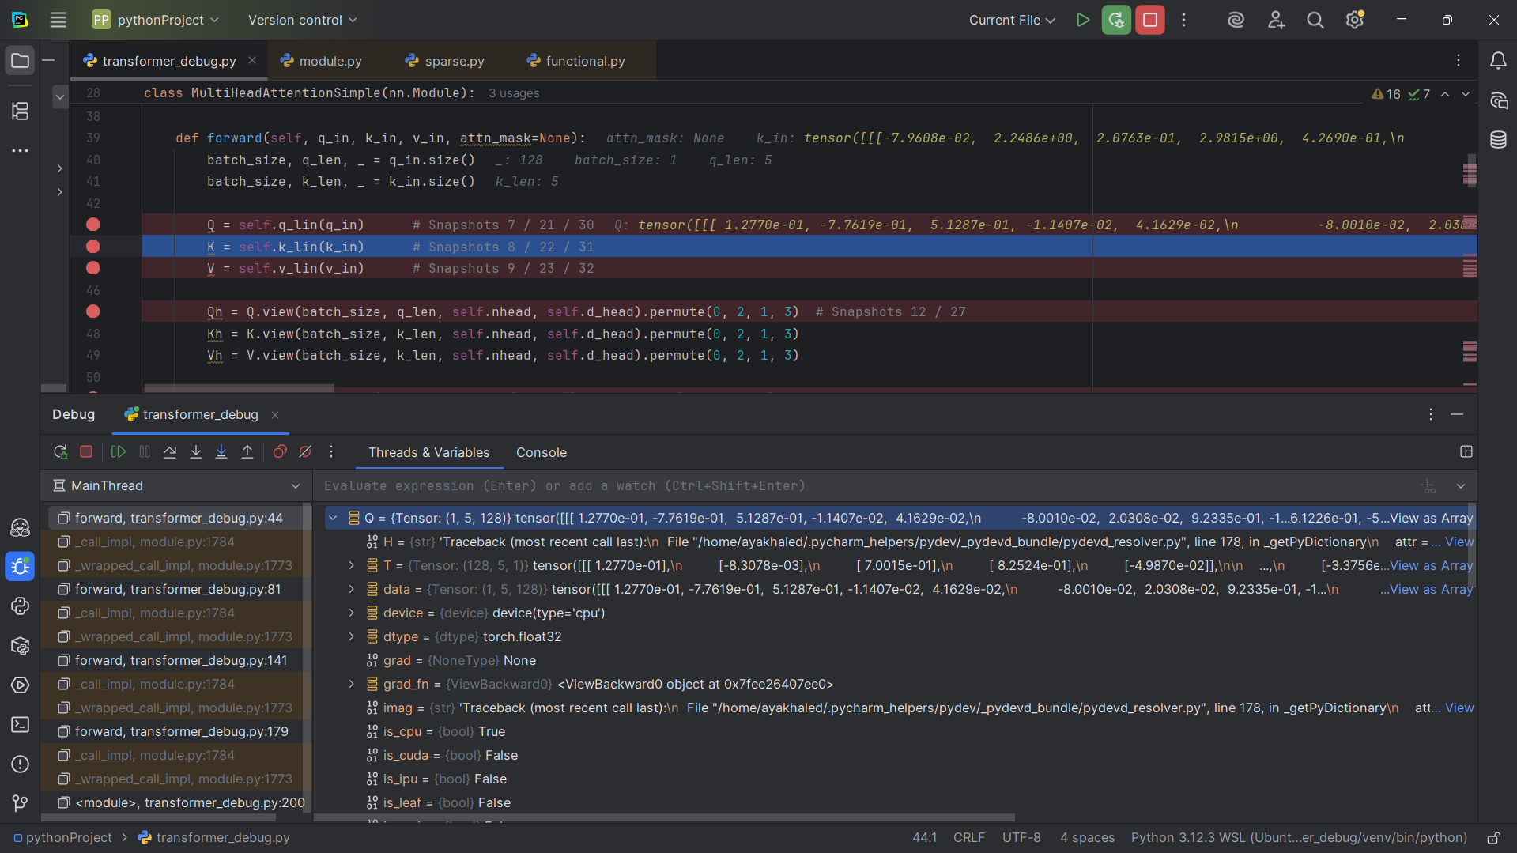

## Snapshot #8: Self-attention keys K

Shape: (1, 5, 128)

Sample values: [4.9897e-01, -1.0123e+00 , -1.1262e-01, . . . ][ -5.5502e-02 , -1.272e-01, -3.9491e-01 , . . . ]

Explanation: K is also a linear projection of the same input. Shape is identical to Q.

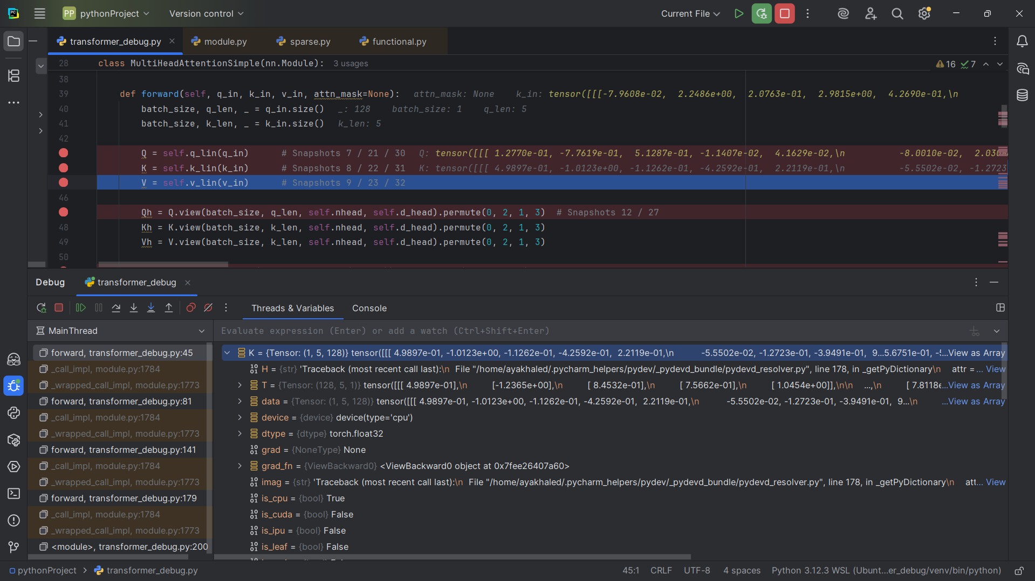

## Snapshot #9: Self-attention values V

Shape: (1, 5, 128)

Sample values: [[-9.535e-02, -4.2892e-01, -1.634e+00, . . . ] , [2.8515e-02 ,

-3.6414e-01, -9.2087e-01, . . .]]

Explanation:V is a projection of the input; unlike Q and K, it carries the content to be weighted and combined.

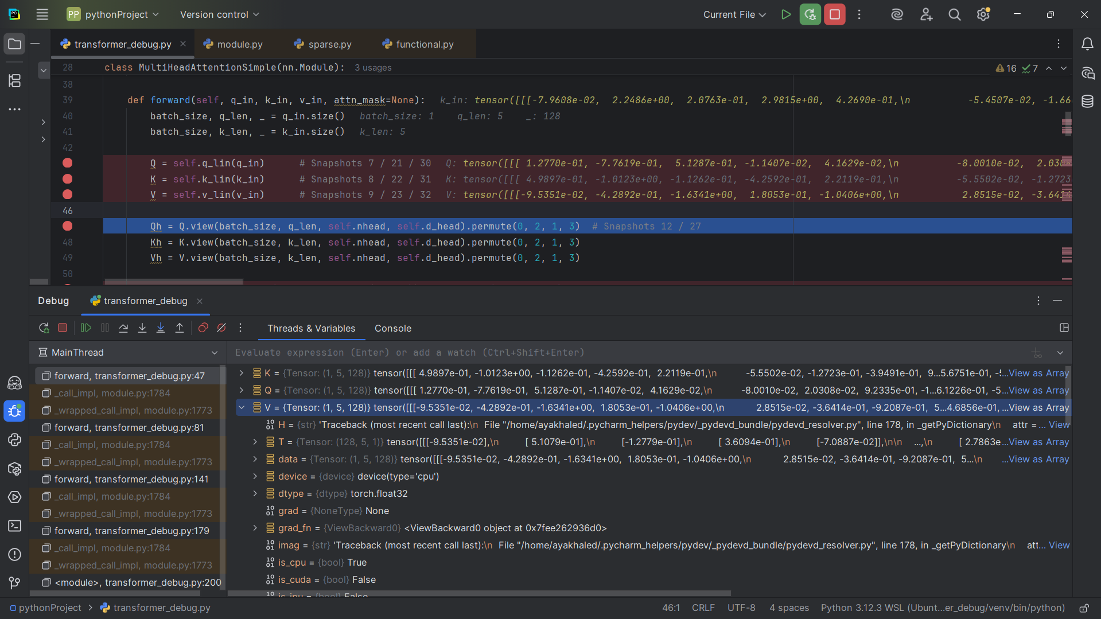

## Snapshot #10: Attention scores before softmax

Shape: (1, 4, 5, 5)

Sample values: [[[[0.3847, -0.715 , -0.9400, . . . ] , [ 0.6749, -0.1109 , -0.2242 , . . .]] , [ . . . ]]

Explanation: This is the raw similarity between queries and keys. Shape is (batch, heads, seq_len, seq_len).

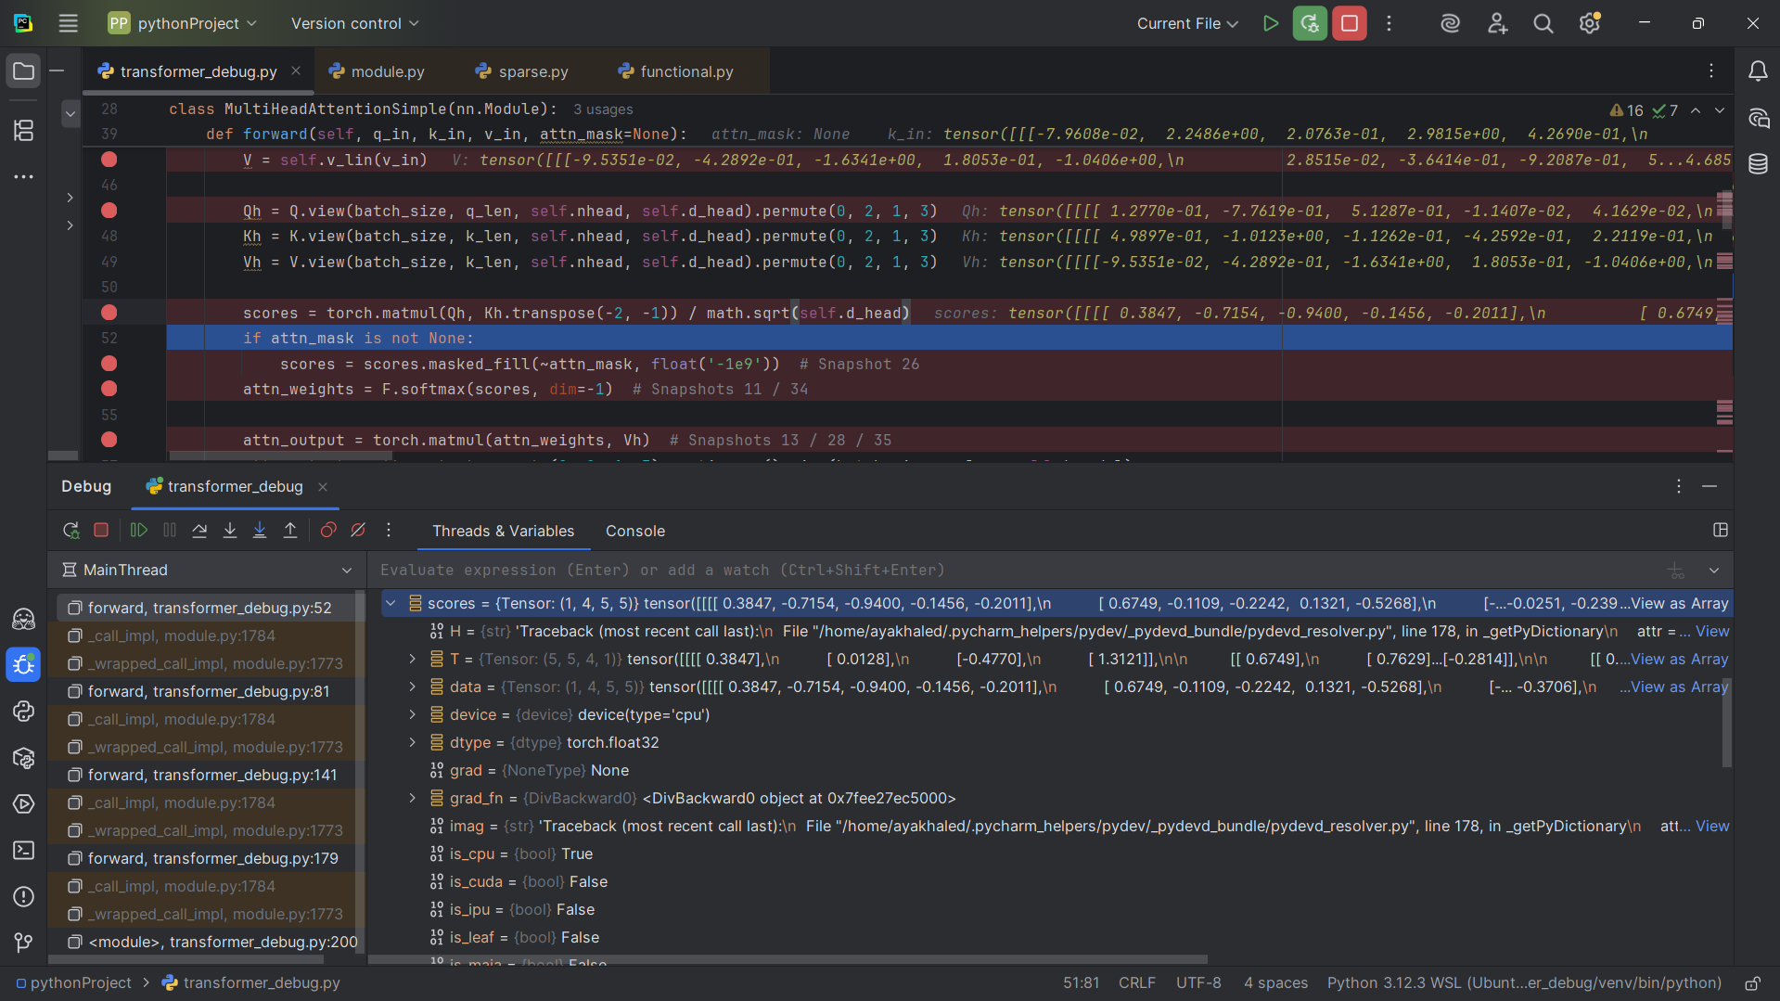

## Snapshot #11: Attention scores after softmax

Shape: (1, 4, 5, 5)

Sample values: [[[[0.3845 , 0.1213 , 0.0989, . . . ] , [ 0.3644, 0.1661 , 0.1483 , . . . ], [ . . . ]]]]

Explanation: Scores are normalized into probabilities across tokens. Each row sums to 1.

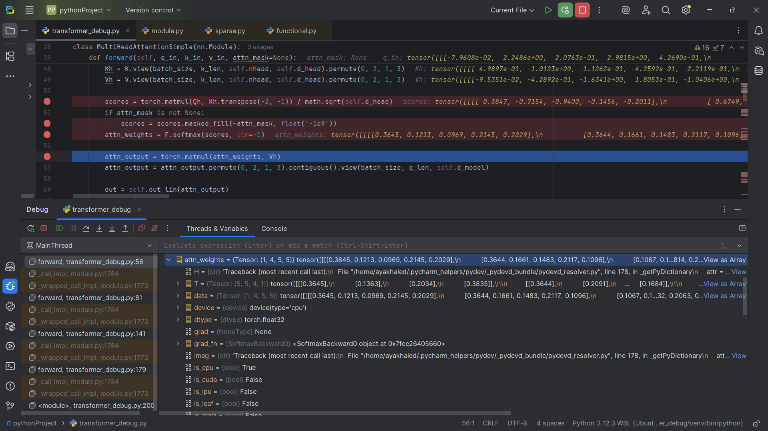

## Snapshot #12: Multi-head split Qh/Kh/Vh

Shapes: {'Qh': (1, 4, 5, 32), 'Kh': (1, 4, 5, 32), 'Vh': (1, 4, 5, 32)}

Sample values: {'Qh': [[[[1.2770e-01 , -7.7619e-01 , 5.1287e-01 , . . . ] , [-8.0010e-02 ,

2.0308e-02 , 9.2335e-01, . . . ] [ . . .]],

'Kh': [[[[4.9897e-01 , -1.0123e+00 , -1.1262e-01 , . . .] , [-5.5502e-02 , -1.2723e-01 ,

-3.9491e-01 , . . . ] [ . . .]],

'Vh': [[[[-9.5351e-02 , -4.2892e-01 , -1.6341e+00 , . . .] , [2.8515e-02 , -3.6414e-01 ,

-9.2087e-01 , . . .] [ . . . ]]}

Explanation: The queries, keys, and values are split into multiple heads. Each head has smaller dimensionality.

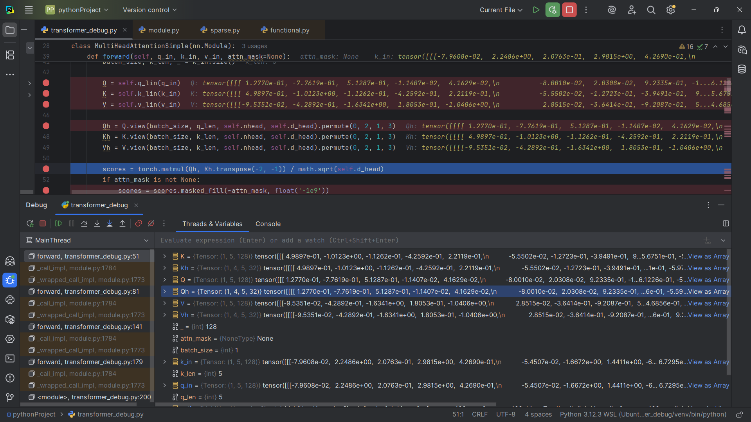

## Snapshot #13: Multi-head attention output after concat

Shape: (1 , 5 , 128)

Sample values: [[[[7.7848e-02 , -2.3560e-01 , -5.8783e-01 , . . . ] , [7.1304e-02 , 6.4408e-2 , . . .] [ . . .]]

Explanation: All heads are recombined back into (batch, seq_len, d_model).

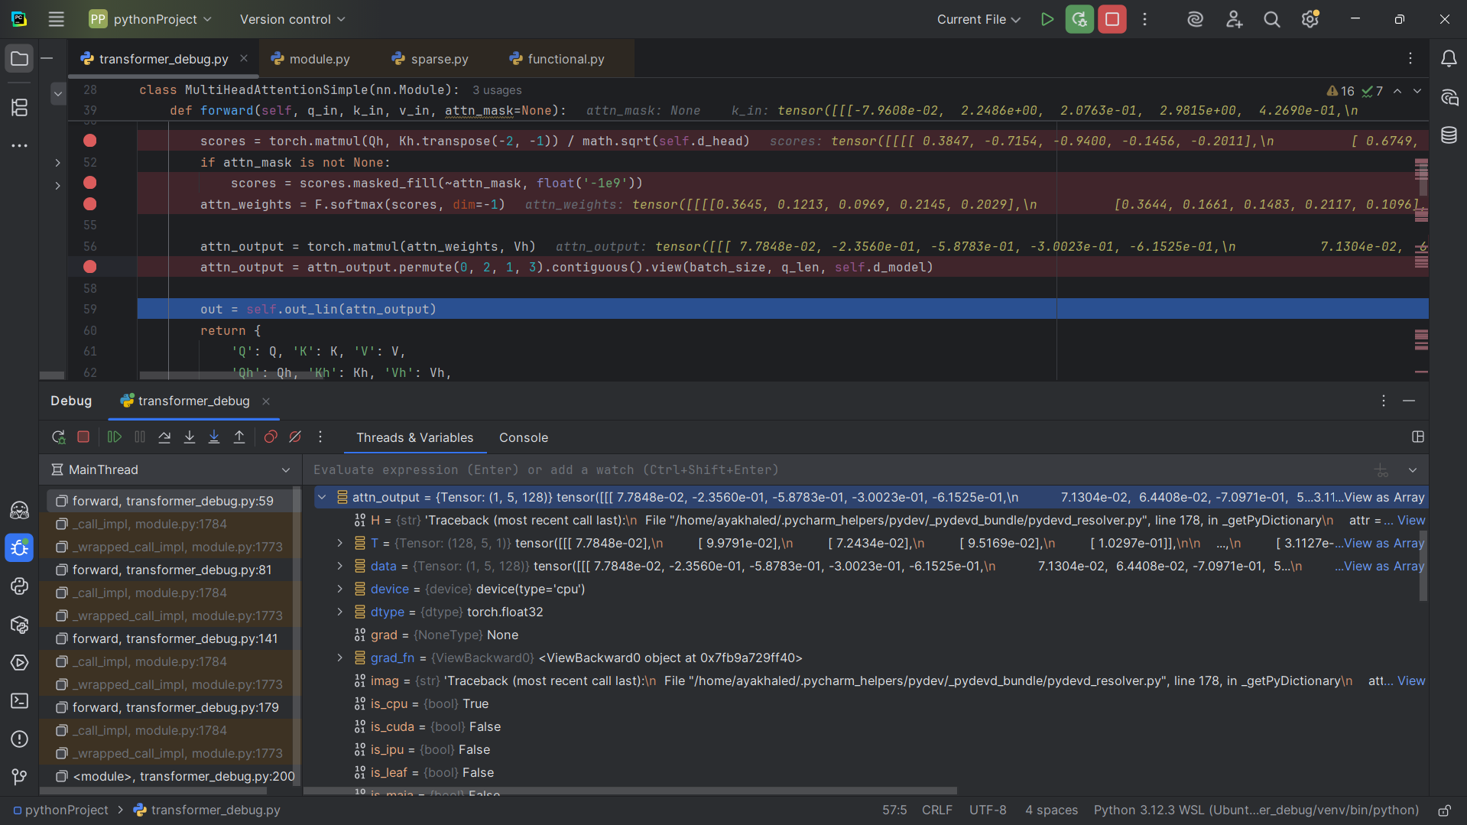

## Snapshot #14: Residual connection after self-attention

Shape: (1, 5, 128)

Sample values: [[[-4.7088e-01 , 2.0425e+00 , 4.2607e-02 , . . . ] , [4.0293e-01 , -1.2244e+00 , . . . ][ . . .]

Explanation: The original input is added to the attention output, preserving information flow.

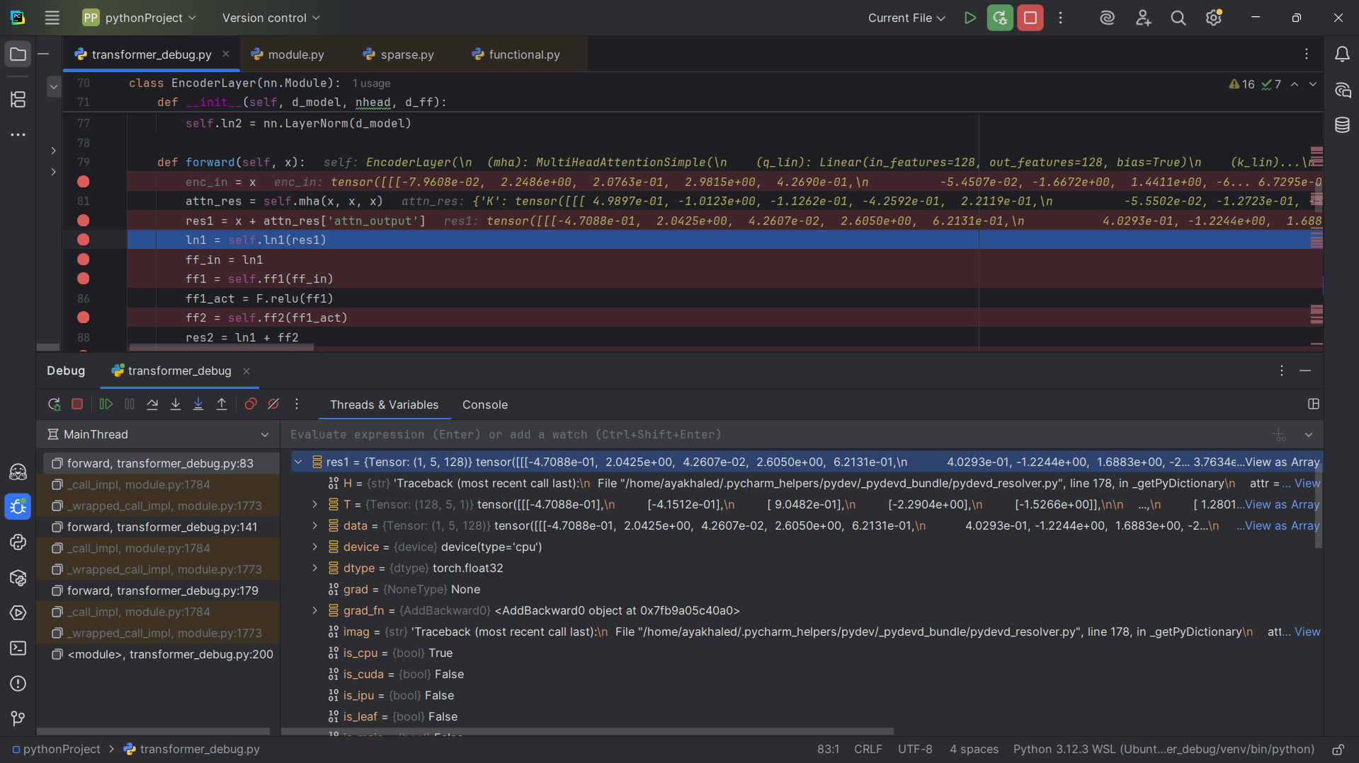

## Snapshot #15: LayerNorm output ln1

Shape: (1, 5, 128)

Sample values: [[[-0.7691 , 1.1948 , -0.3679 , . . . ] , [0.9180 , -0.4242 , 1.5509], [. . .]]

Explanation: Normalization keeps activations stable and ensures consistent scale.

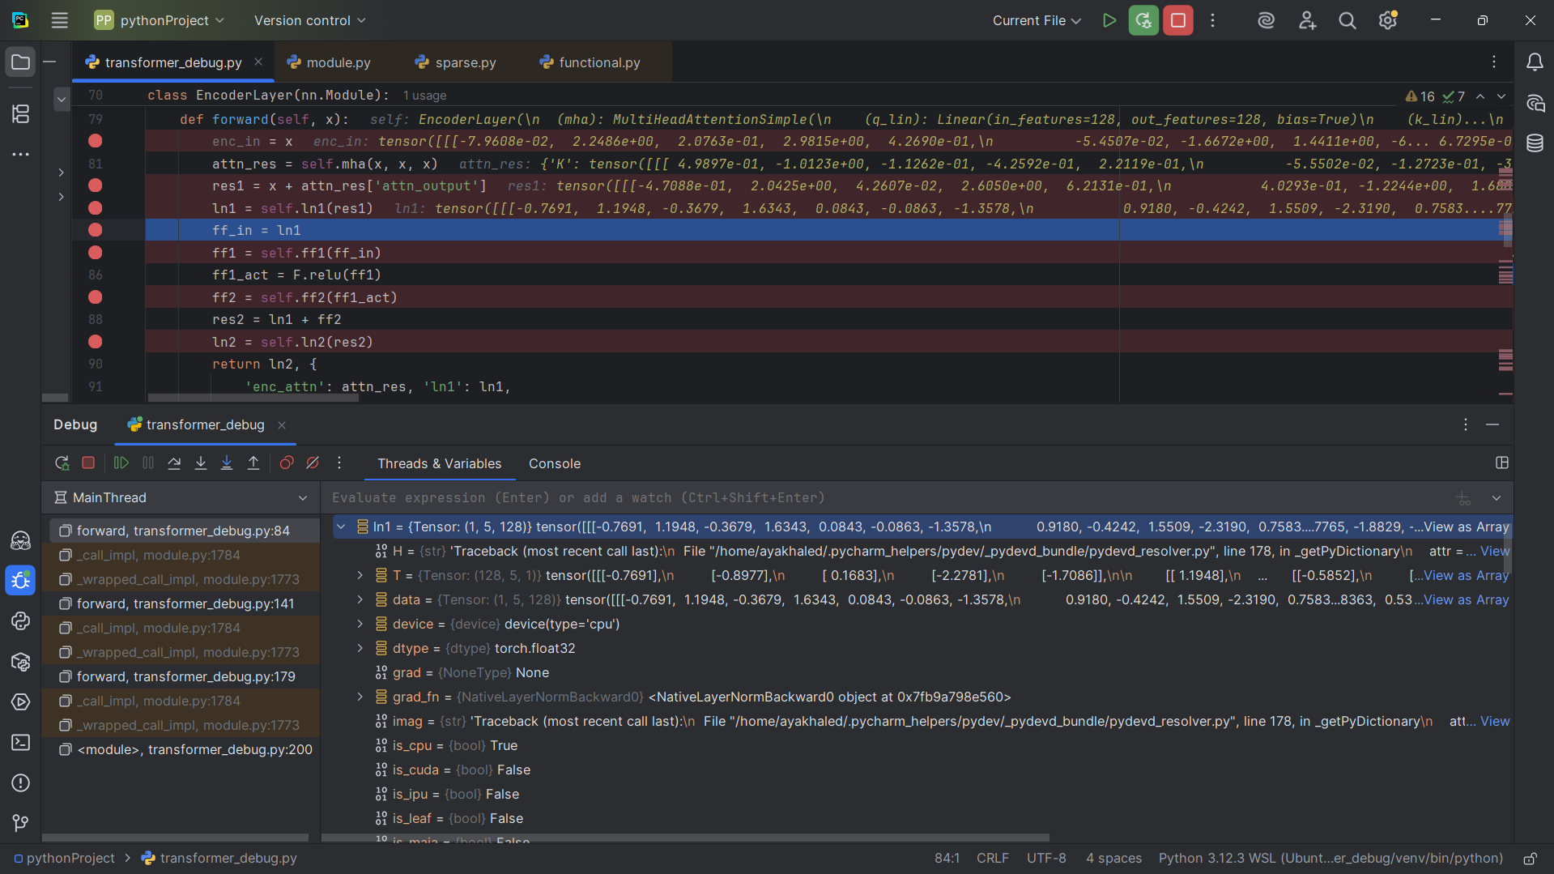

## Snapshot #16: Feed-forward input

Shape: (1, 5, 128)

Sample values: [[-0.7691 , 1.1948 , -0.3679, . . . ] , [ 0.9180, -0.4242, 1.5509, . . . ] [. . .]]

Explanation: The normalized tensor is fed into the position-wise feed-forward network.

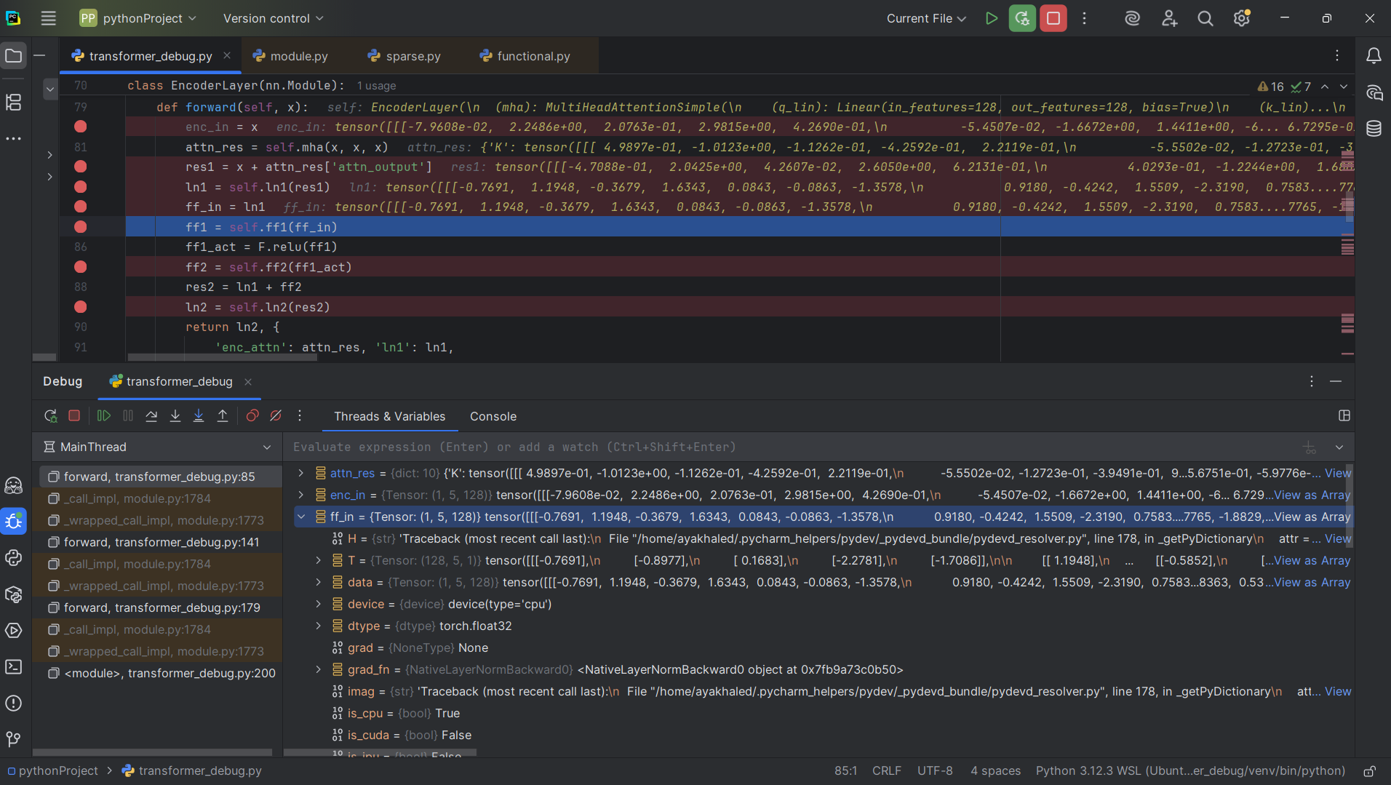

## Snapshot #17: FFN first linear output (ff1)

Shape: (1, 5, 512)

Sample values: [[0.3041, 0.2028, -0.8112, . . . ] , [0.4629 , -0.4896, 0.1248, . . . ] [ . . . ]]

Explanation: The tensor is expanded to a higher dimension (d_ff) before applying ReLU.

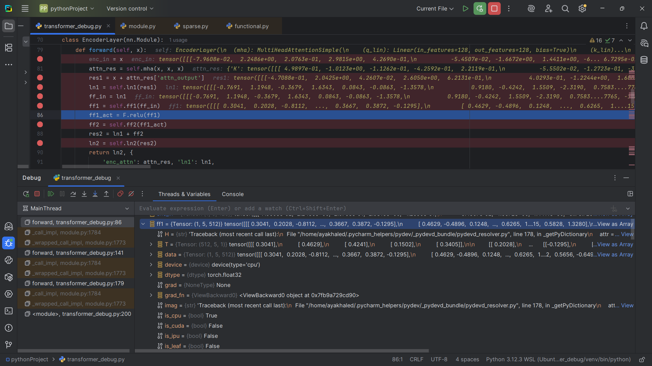

## Snapshot #18: FFN second linear output (ff2)

Shape: (1, 5, 128)

Sample values: [[3.5626e-02 , 1.7637e-02, -6.1296e-02 , . . . ] , [8.6495e-02 , -2.7239e-02 , . . . ] [ . . . ]]

Explanation: The tensor is projected back down to d_model for compatibility.

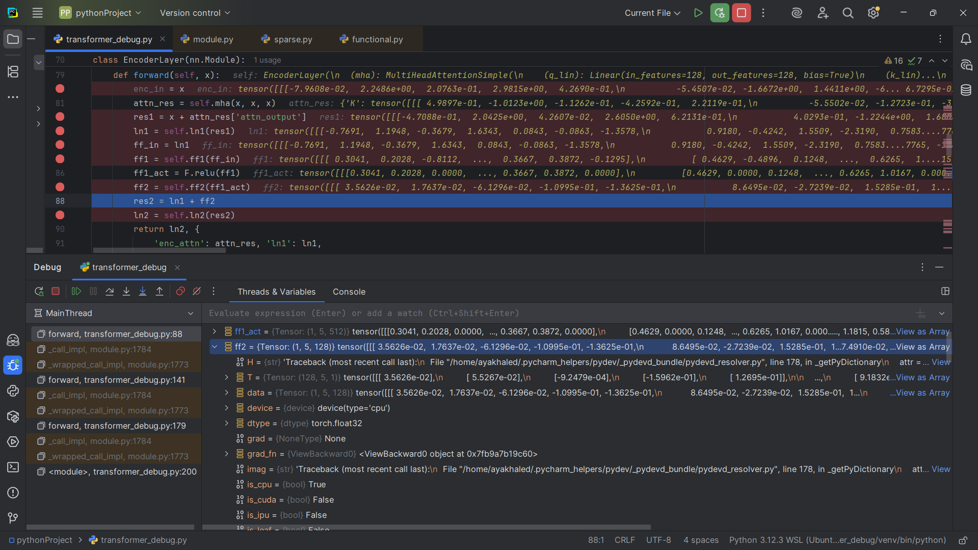

## Snapshot #19: Encoder block final output (ln2)

Shape: (1, 5, 128)

Sample values: [[-0.7271 , 1.1661 , -0.4311 , . . .] , [1.0284 , -0.2544 , 1.2844 , . . .] [. . .]]

Explanation: The final output of this encoder layer, ready to be passed to the next encoder or the decoder.

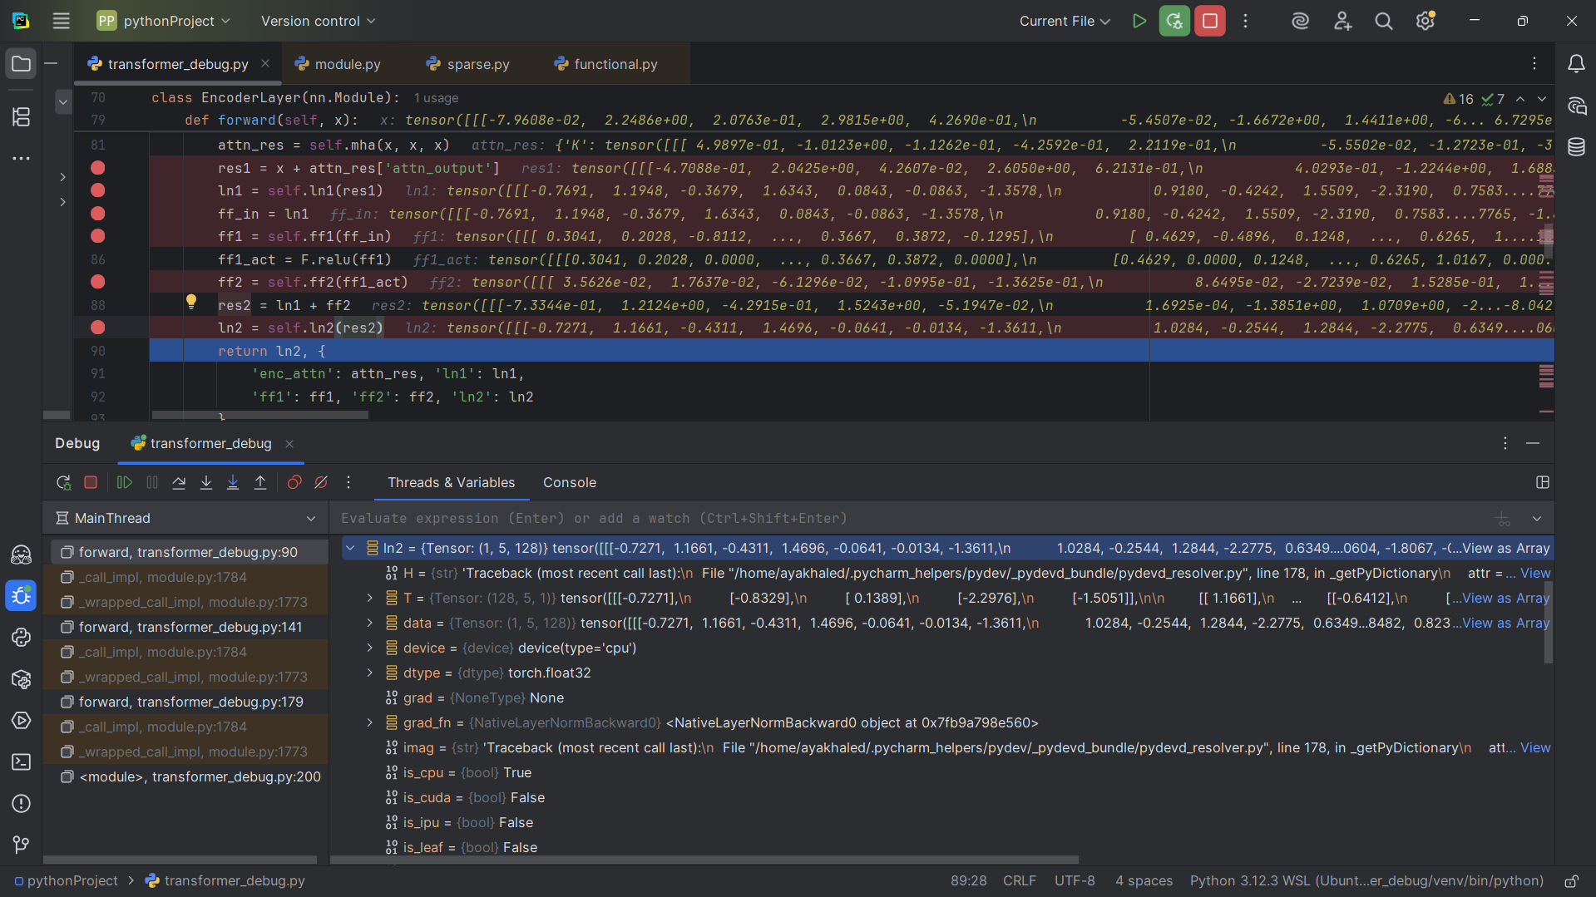

## Snapshot #20: Decoder block input tensor

Shape: (1, 5, 128)

Sample values: [[-1.5366e+00 , 1.4869e+00 , 1.6594e+00, . . .] , [ 4.3054e-01 ,

-1.0361e+00 , . . ] [ . . .]]

Explanation: This is the input to the decoder layer, after embeddings and positional encoding.

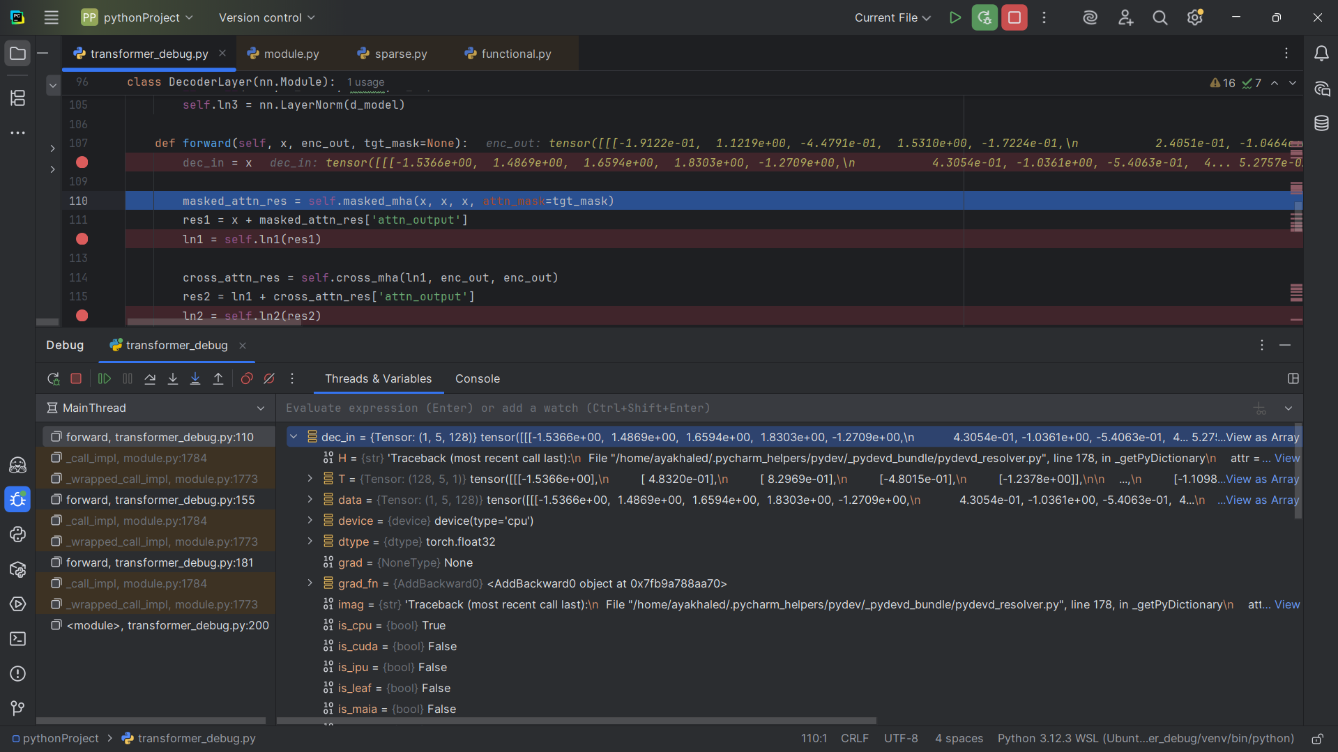

## Snapshot #21: Masked self-attention Q

Shape: (1, 5, 128)

Sample values: [[9.7235e-01 , 6.6454e-01 , 1.8011e-01 , . . .] , [5.0739e-02 , -2.3350e-01 , . . . ] [ . . . ]]

Explanation: Q comes from the decoder input, projected into query space.

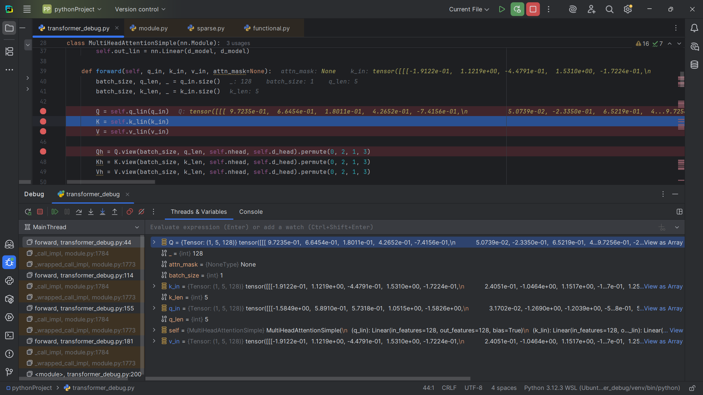

## Snapshot #22: Masked self-attention K

Shape: (1, 5, 128)

Sample values: [[7.8153e-01 , -8.9940e-01 , 9.8791e-01 , . . .] , [4.0277e-01 , -3.1098e-01, . . .] [. . .]]

Explanation: K is projected from the decoder input, used with Q to compute attention scores.

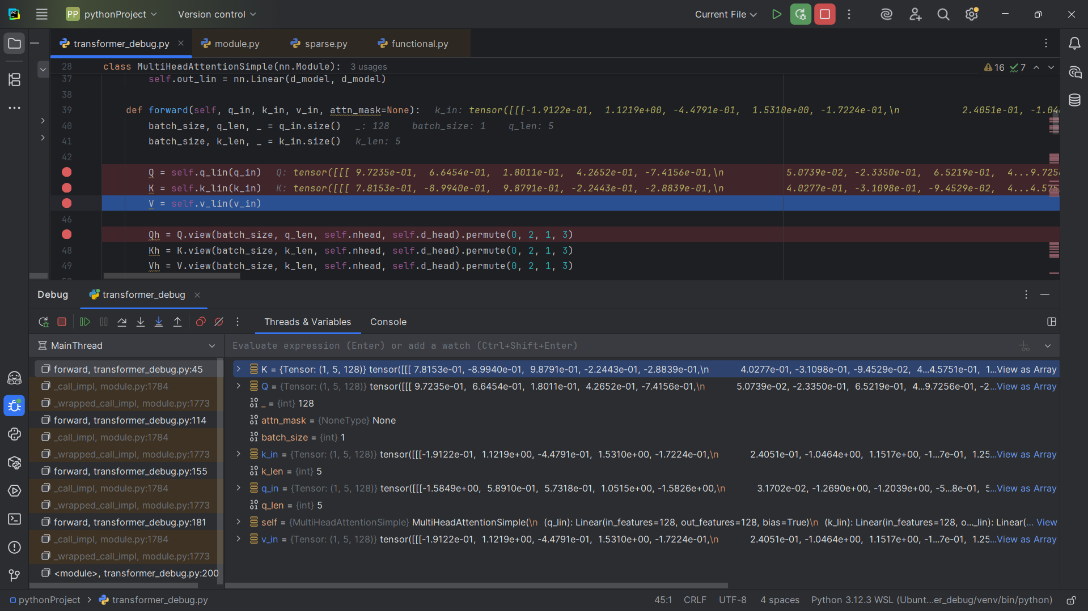

## Snapshot #23: Masked self-attention V

Shape: (1, 5, 128)

Sample values: [[0.0577 , -0.5828 , 0.4678 , . . . ] , [-1.3472 , 0.0549 , 1.2289 , . . .] [ . . .]]

Explanation: V is also projected from the decoder input; these vectors will be weighted by attention.

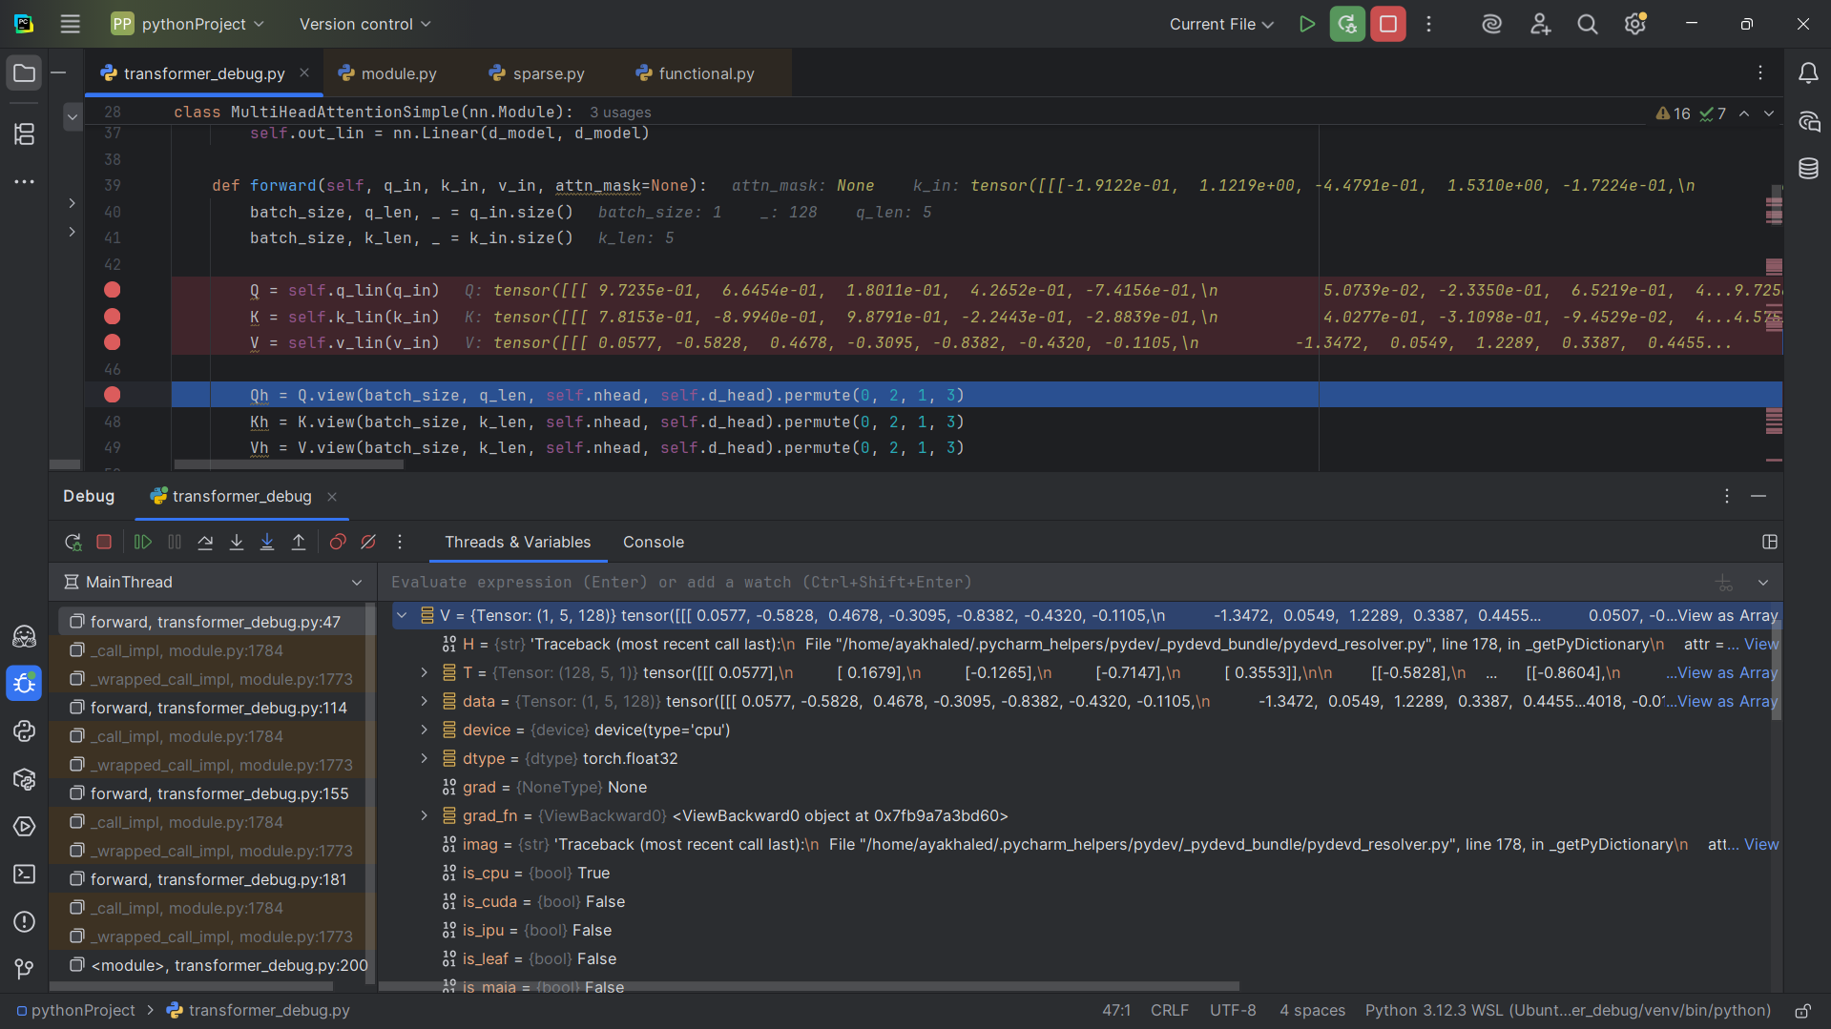

## Snapshot #24: Masked attention scores before mask

Shape: (1, 4, 5, 5)

Sample values: [[0.4562 , 0.7417 , 0.2743 , . . .] , [0.5291 , 0.1336 , -0.1137 , . . .] , [ . . . ] , [ . . . ]]

Explanation: Similarity scores between queries and keys are computed, but not yet normalized.

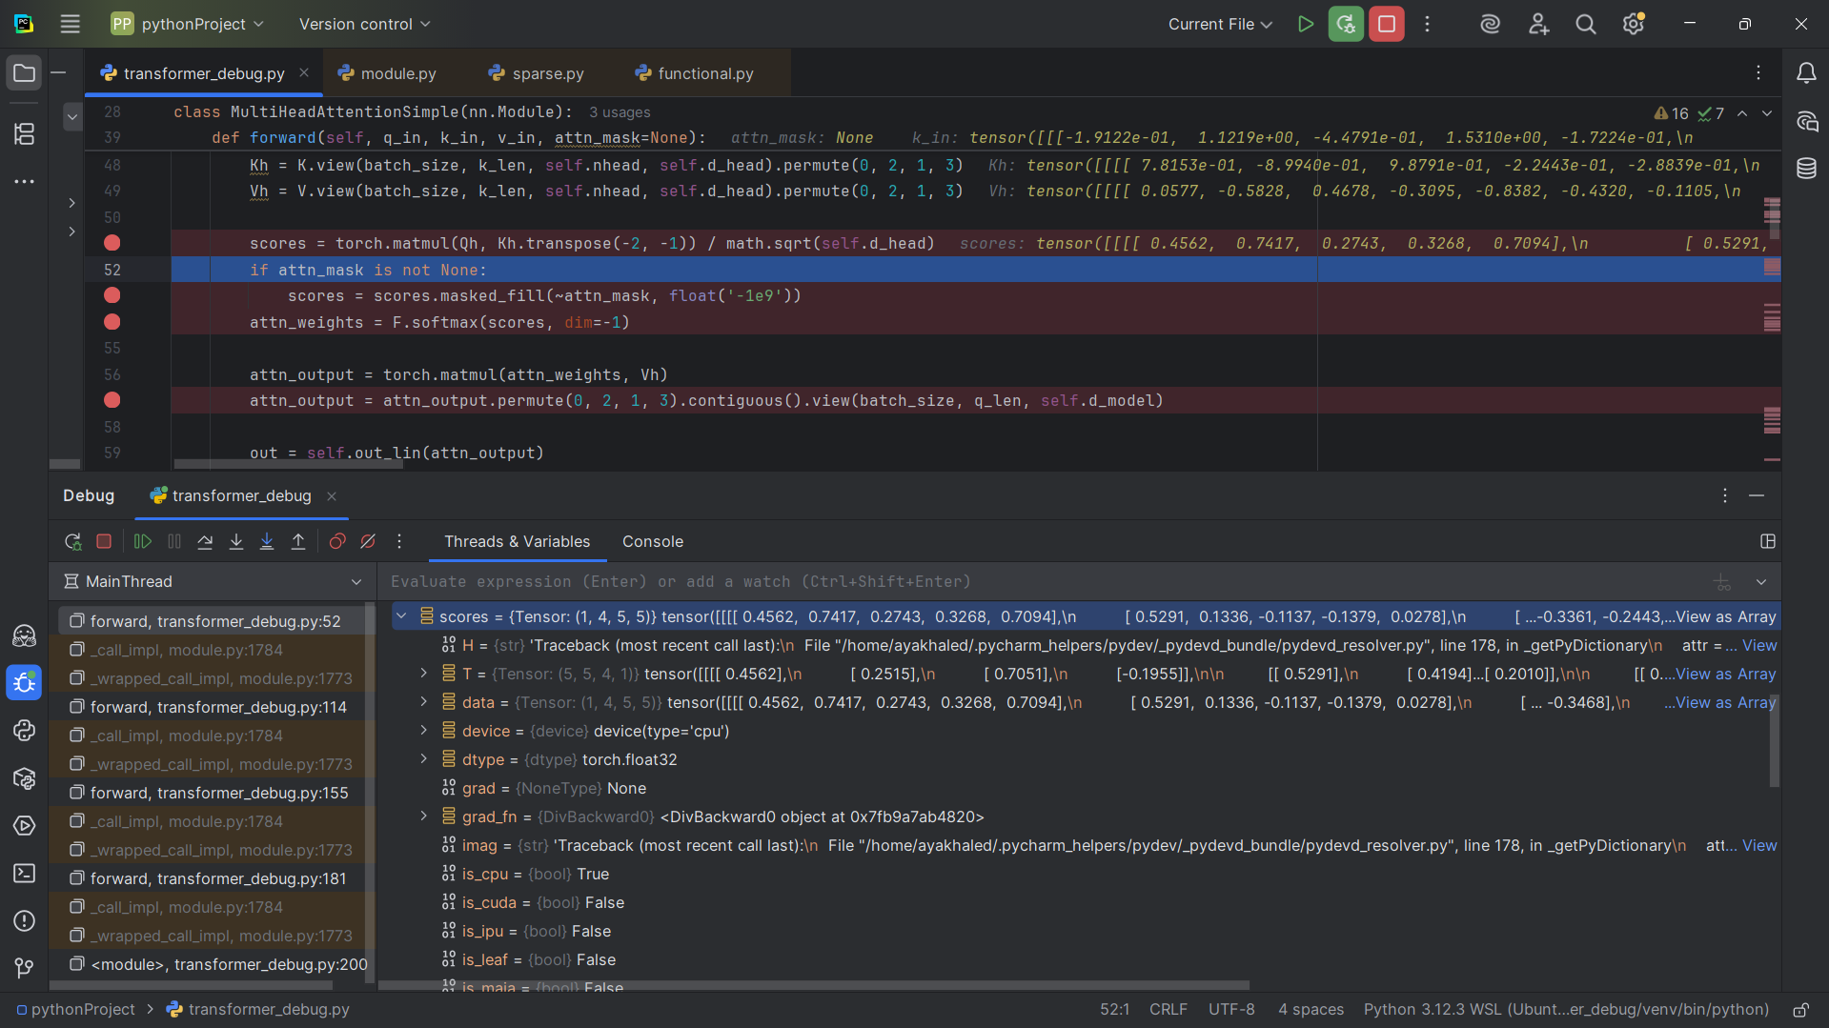

## Snapshot #25: Mask tensor (lower-triangular)

Shape: (1, 1, 5, 5)

Sample values: [[True, False, False, False, False] , [True , True , False , False , False ] , [ . . . ] , [ . . . ]]

**Explanation:** The triangular mask blocks each position from attending to future tokens. The debugger shows it as True/False, but in practice True = valid (0) and False = masked (−inf), enforcing causal masking.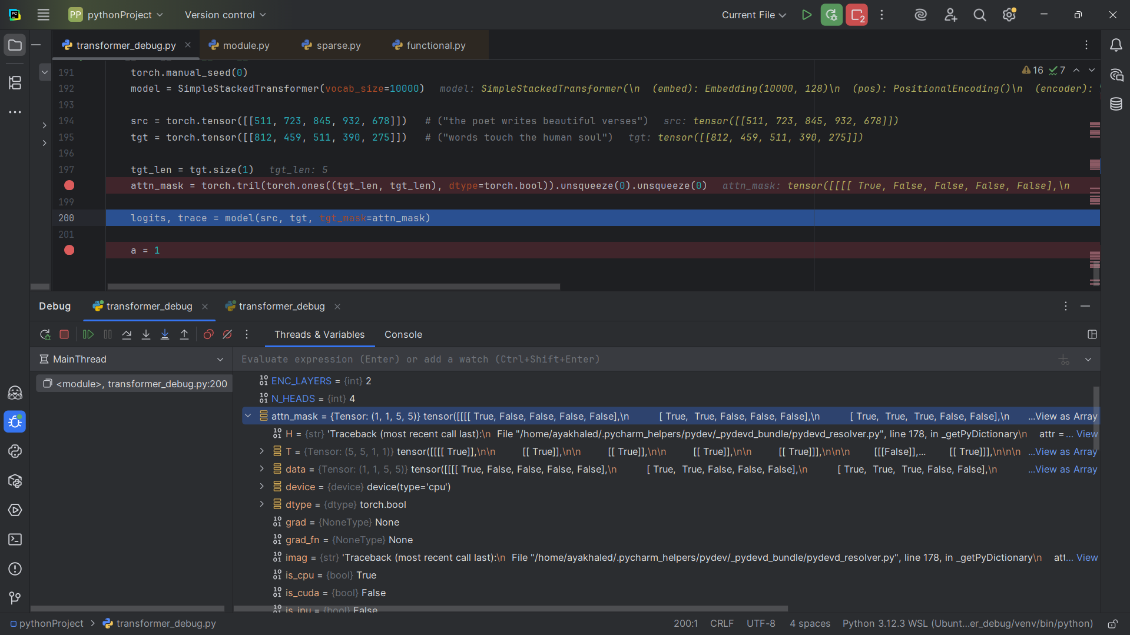

## Snapshot #26: Masked attention scores after mask and softmax

Shape: (1, 4, 5, 5) Sample values: [[1.0000, 0.0000, 0.0000, . . . ] , [0.3680, 0.6320,0.0000, . . .] [ . . . ] [ . . . ]]

**Explanation:** Masked positions are set to large negative values (≈ -1e9). After softmax, they become 0.0 while valid positions are normalized, ensuring causal masking.

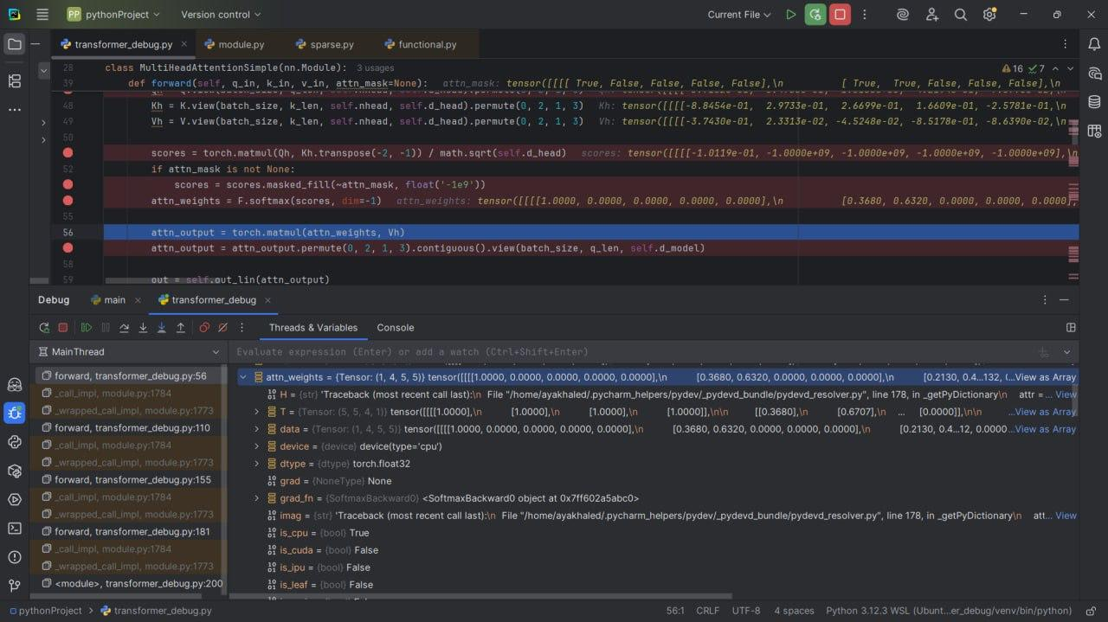

## Snapshot #27: Masked self-attention multi-head split

Shapes: {'Qh': (1, 4, 5, 32), 'Kh': (1, 4, 5, 32), 'Vh': (1, 4, 5, 32)}

Sample values: {'Qh': [[3.7102e-01 , -5.4758e-01 , -1.0136e+00 , . . .] , [-5.1188e-01 , 8.0541e-02 , . . .][ . . . ][ . . . ]],

'Kh': [[-8.8454e-01 , 2.9733e-01 , 2.6699e-01 , . . .] [-6.5548e-01 , -2.8999e-01 , . . .] [ . . . ] [ . . . ]],

'Vh': [-3.7430e-01 , 2.3313e-02 , -4.5248e-02 , . . .] , [6.4531e-01 , . . . ] , [ . . . ] [ . . . ]]}

Explanation: The queries are divided into multiple heads for parallel attention.

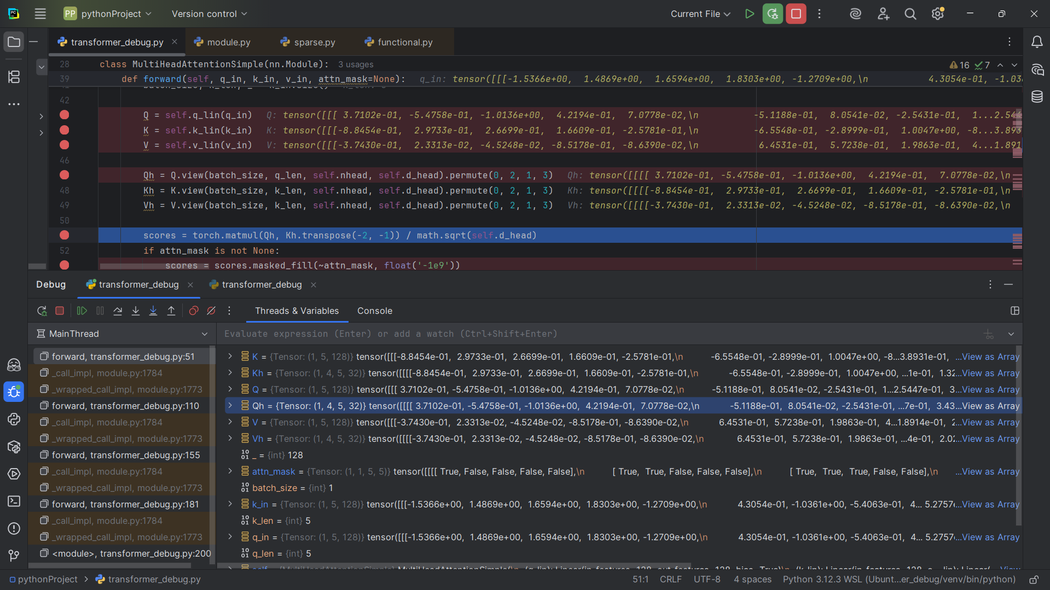

## Snapshot #28: Masked self-attention concatenated output

Shape: (1, 5, 128)

Sample values: [[-3.7430e-01 , 2.3313e-02, -4.5248e-02, . . .] , [6.4531e-01 , . . . ] [ . . . ]]

Explanation: All head outputs are concatenated back into (batch, seq_len, d_model).

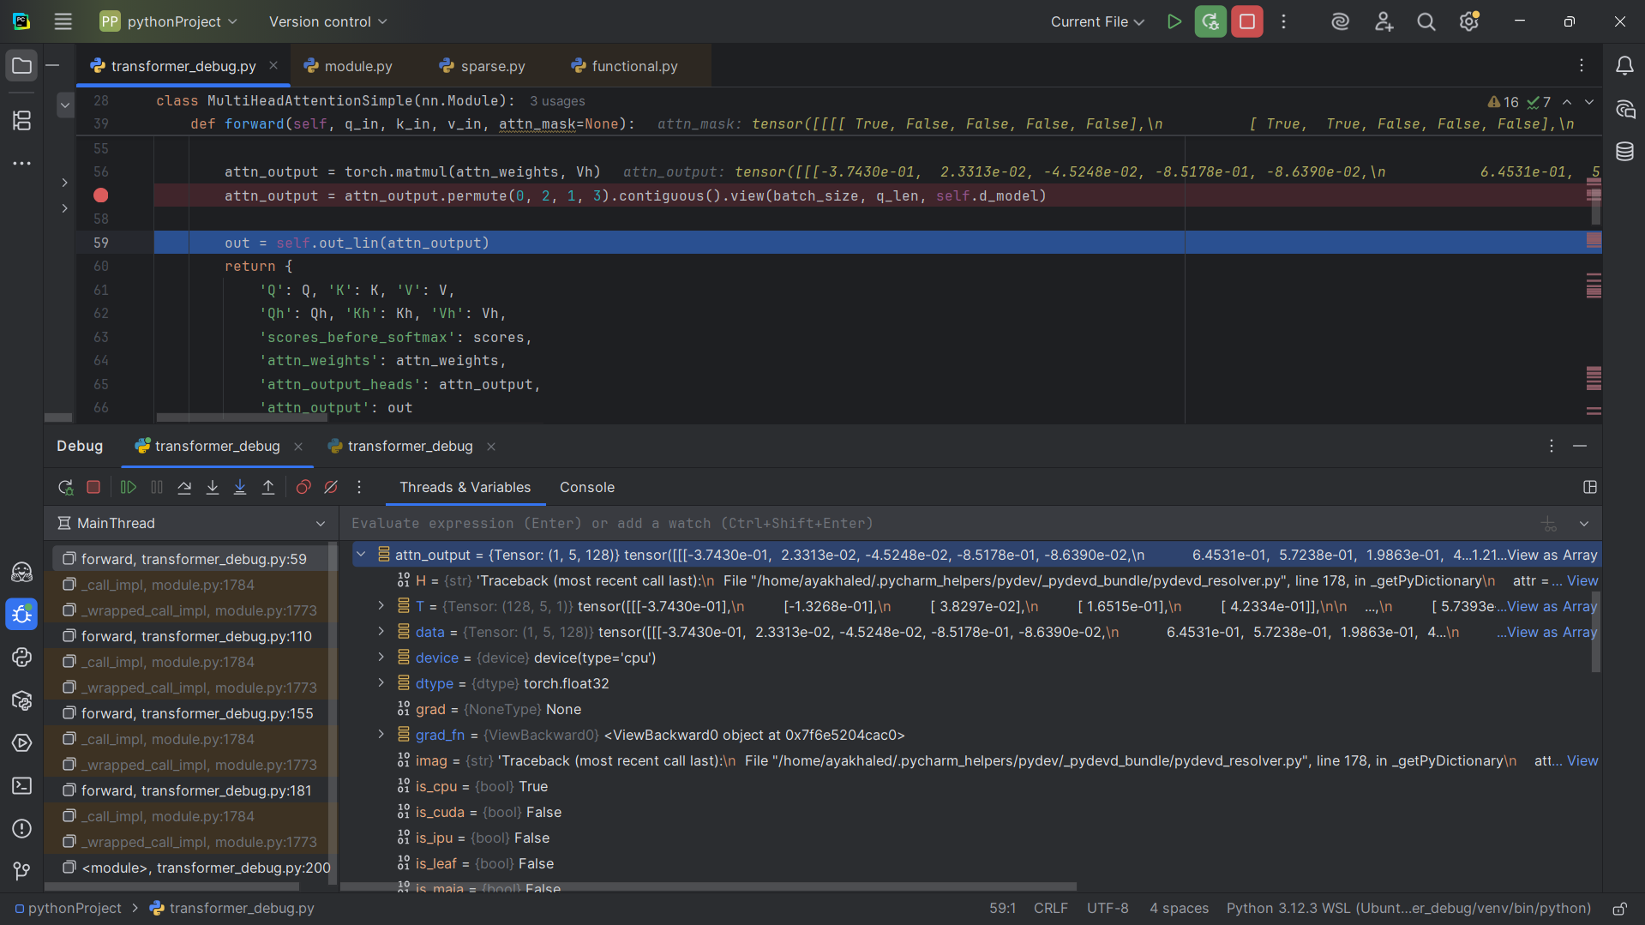

## Snapshot #29: Residual + LayerNorm after masked self-attention

Shape: (1, 5, 128)

Sample values: [[-1.5849e+00, 5.8910e-01, 5.7318e-01, . . . ] , [ 3.1702e-02 ,

-1.2690e+00 , . . . ] [ . . . ]]

Explanation: Residual connection and normalization stabilize the decoder input.

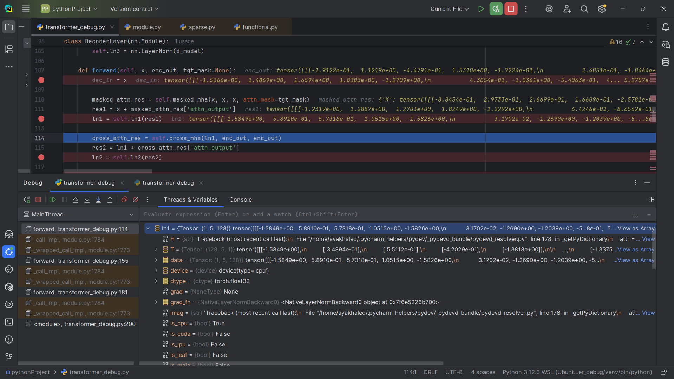

## Snapshot #30: Cross-attention queries (Q)

Shape: (1, 5, 128)

Sample values: [[9.7235e-01 , 6.6454e-01 , 1.8011e-01 , . . . ] , [5.0739e-02 , -2.3350e-01 , . . . ] [ . . . ]]

Explanation: The decoder output becomes queries for attending to encoder outputs.

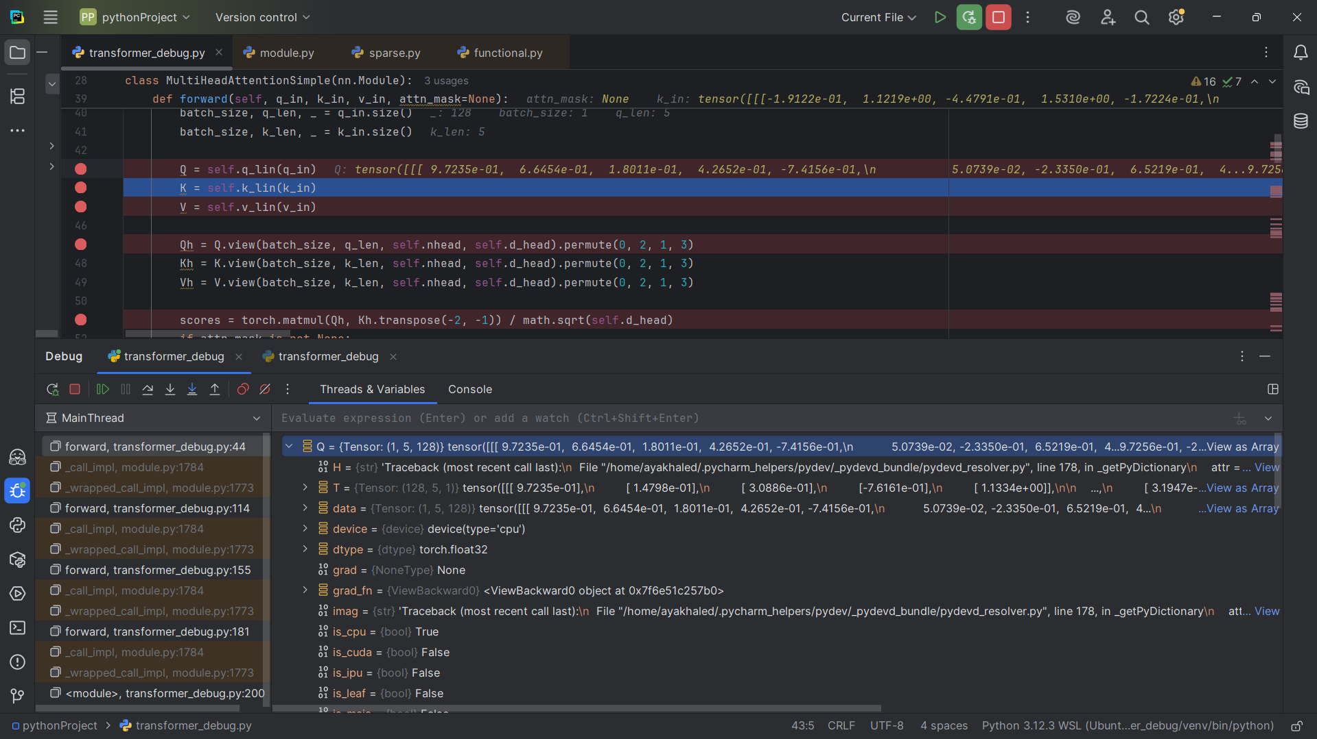

## Snapshot #31: Cross-attention keys (K)

Shape: (1, 5, 128)

Sample values: [[7.8153e-01, -8.9940e-01 , 9.8791e-01 , . . . ] , [4.0277e-01 , -3.1098e-01 , . . .] [ . . . ]]

Explanation: Keys are projected from the encoder outputs, representing source sequence positions.

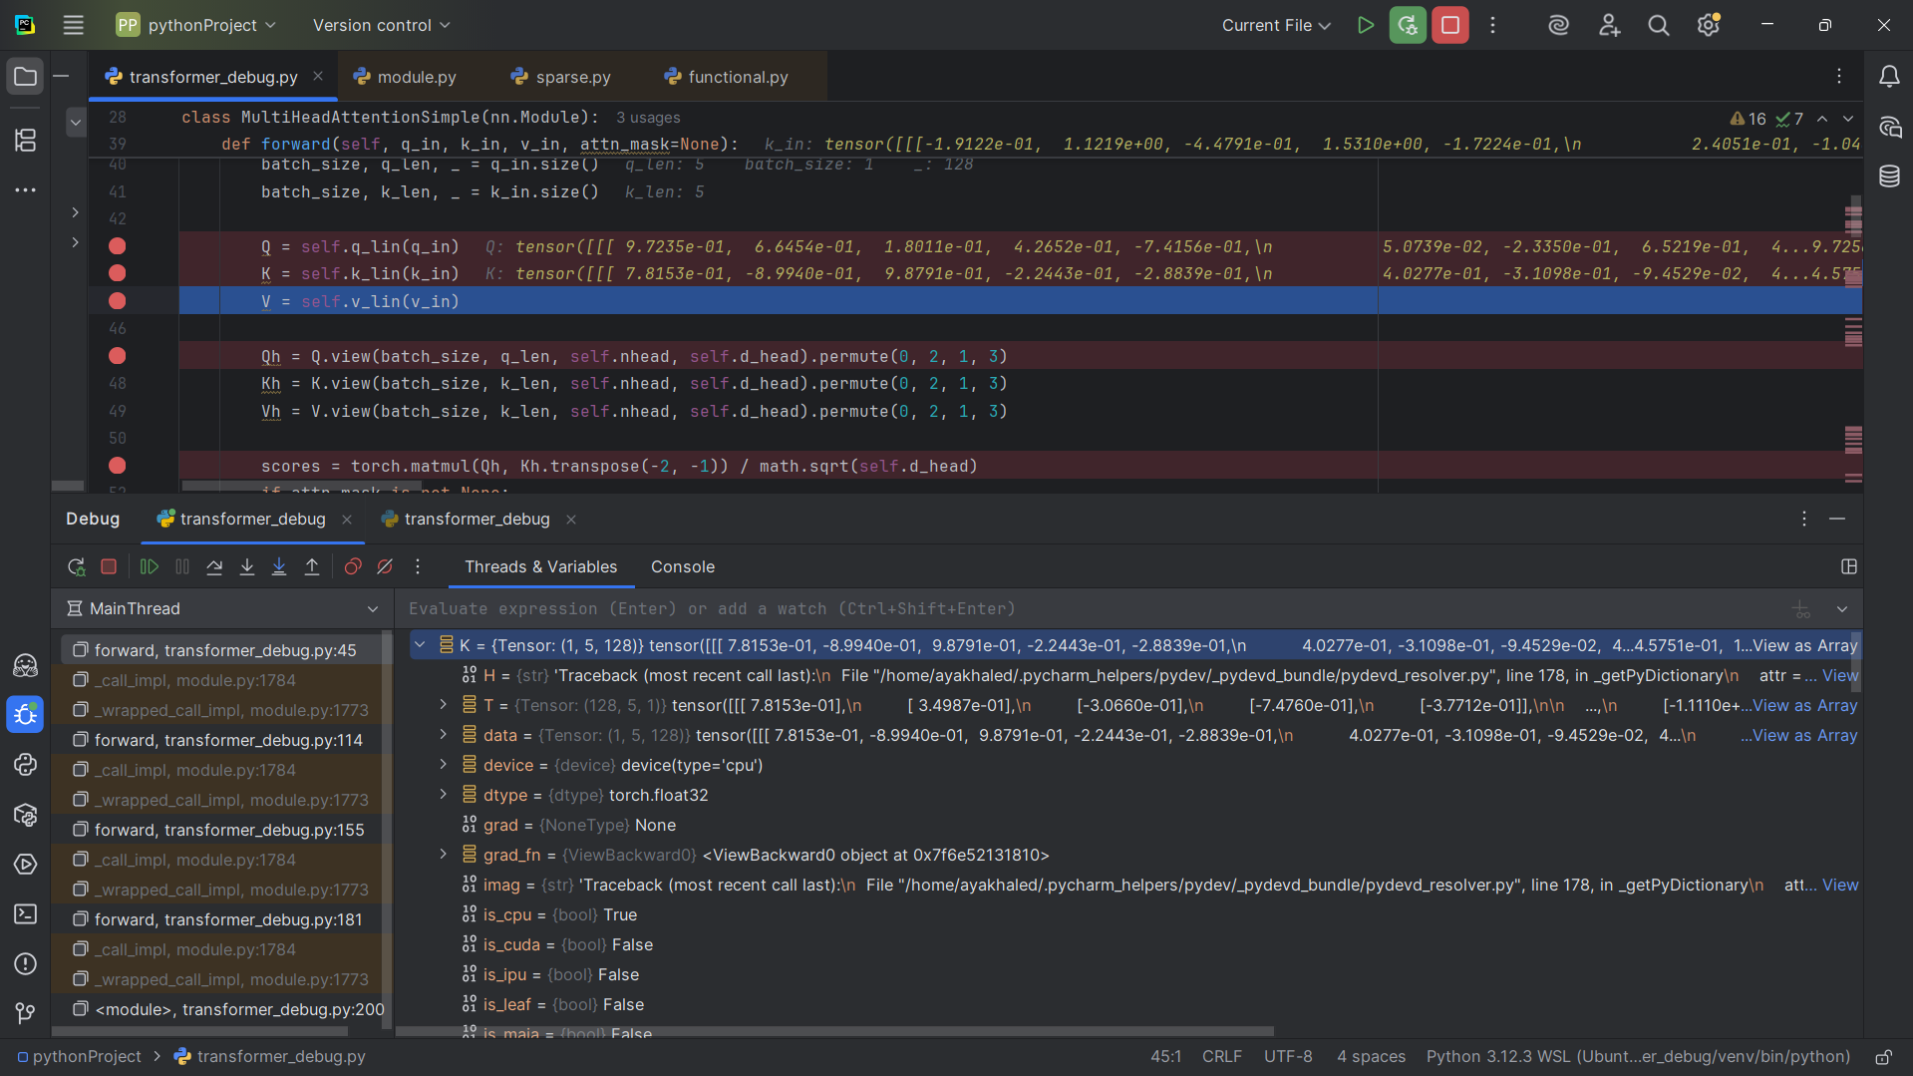

## Snapshot #32: Cross-attention values (V)

Shape: (1, 5, 128)

Sample values: [[0.0577 , -0.5828 , 0.4678 , . . . ] , [ -1.3472 , 0.0549 , . . . ] [ . . . ]]

Explanation: Values are projected from encoder outputs, carrying the actual source information.

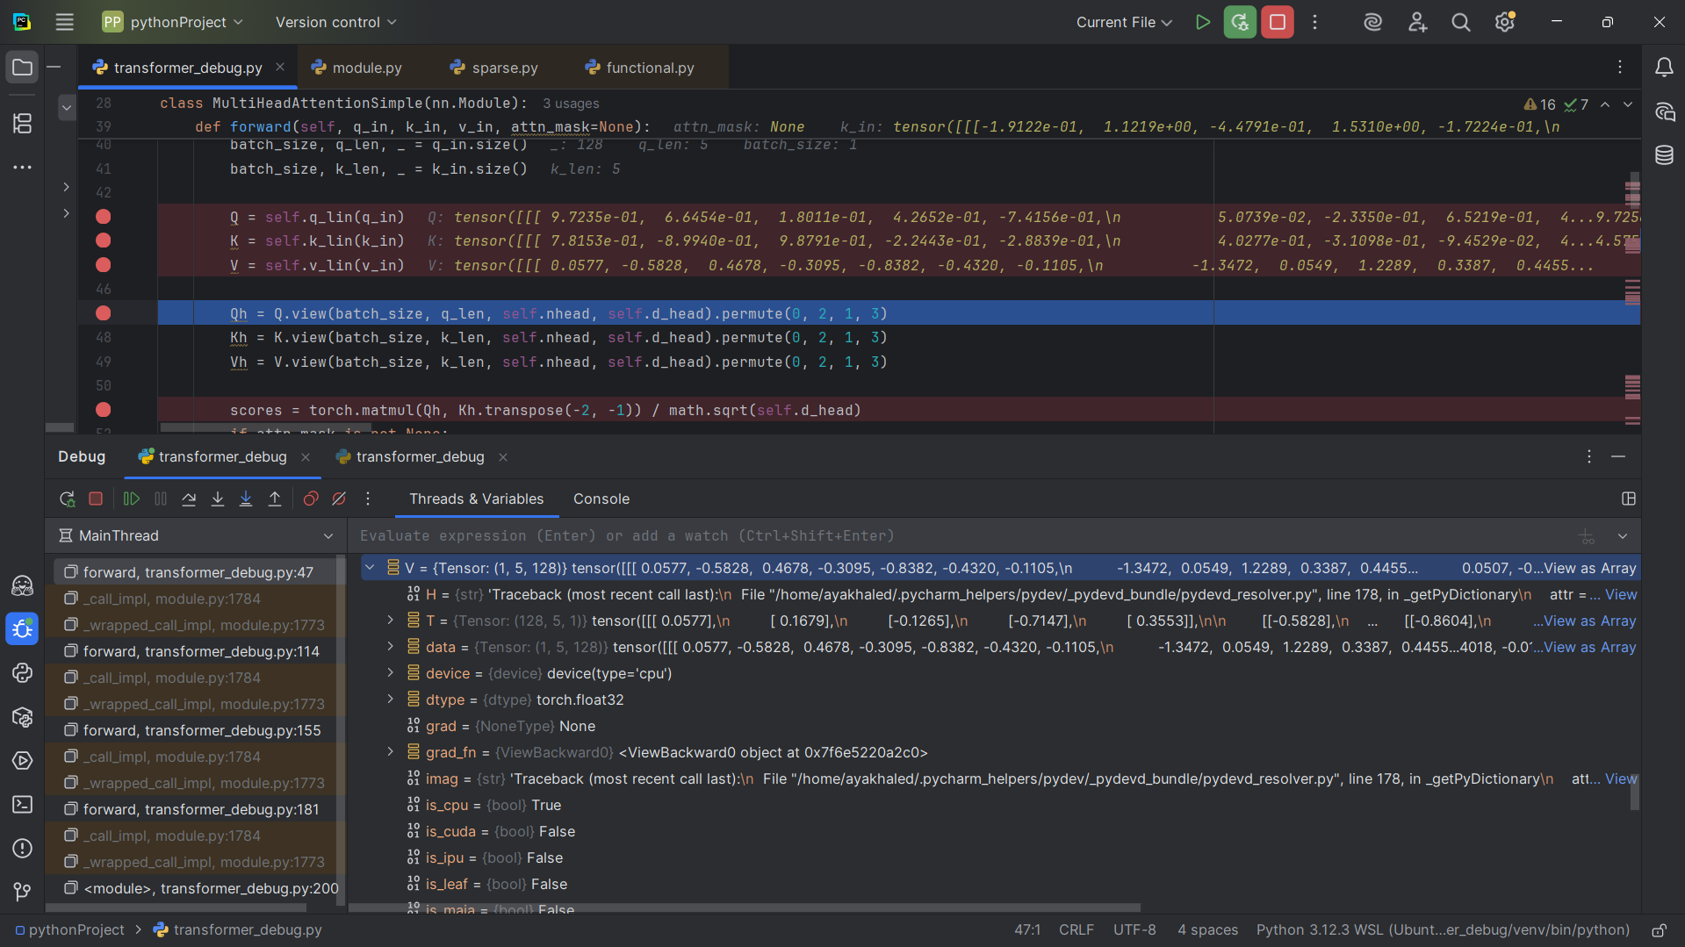

## Snapshot #33: Cross-attention scores before softmax

Shape: (1, 4, 5, 5)

Sample values: [[0.4562 , 0.7417 , 0.2743 , . . . ] , [0.5291 , 0.1336 , . . . ] , [ . . . ] [ . . .]]

Explanation: Dot products between decoder queries and encoder keys, showing similarity.

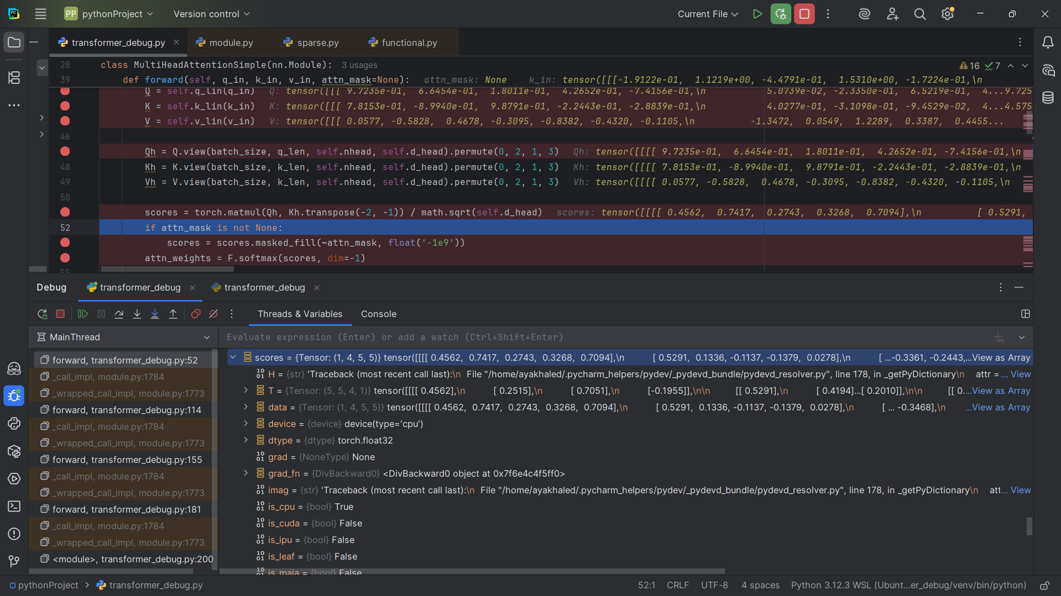

## Snapshot #34: Cross-attention scores after softmax

Shape: (1, 4, 5, 5)

Sample values: [[0.1876 , 0.2496 , 0.1564 , . . . ] , [0.3014 , 0.2029 , . . . ] [ . . . ] [ . . . ]]

Explanation: Normalized probabilities indicating how much each decoder token attends to encoder tokens.

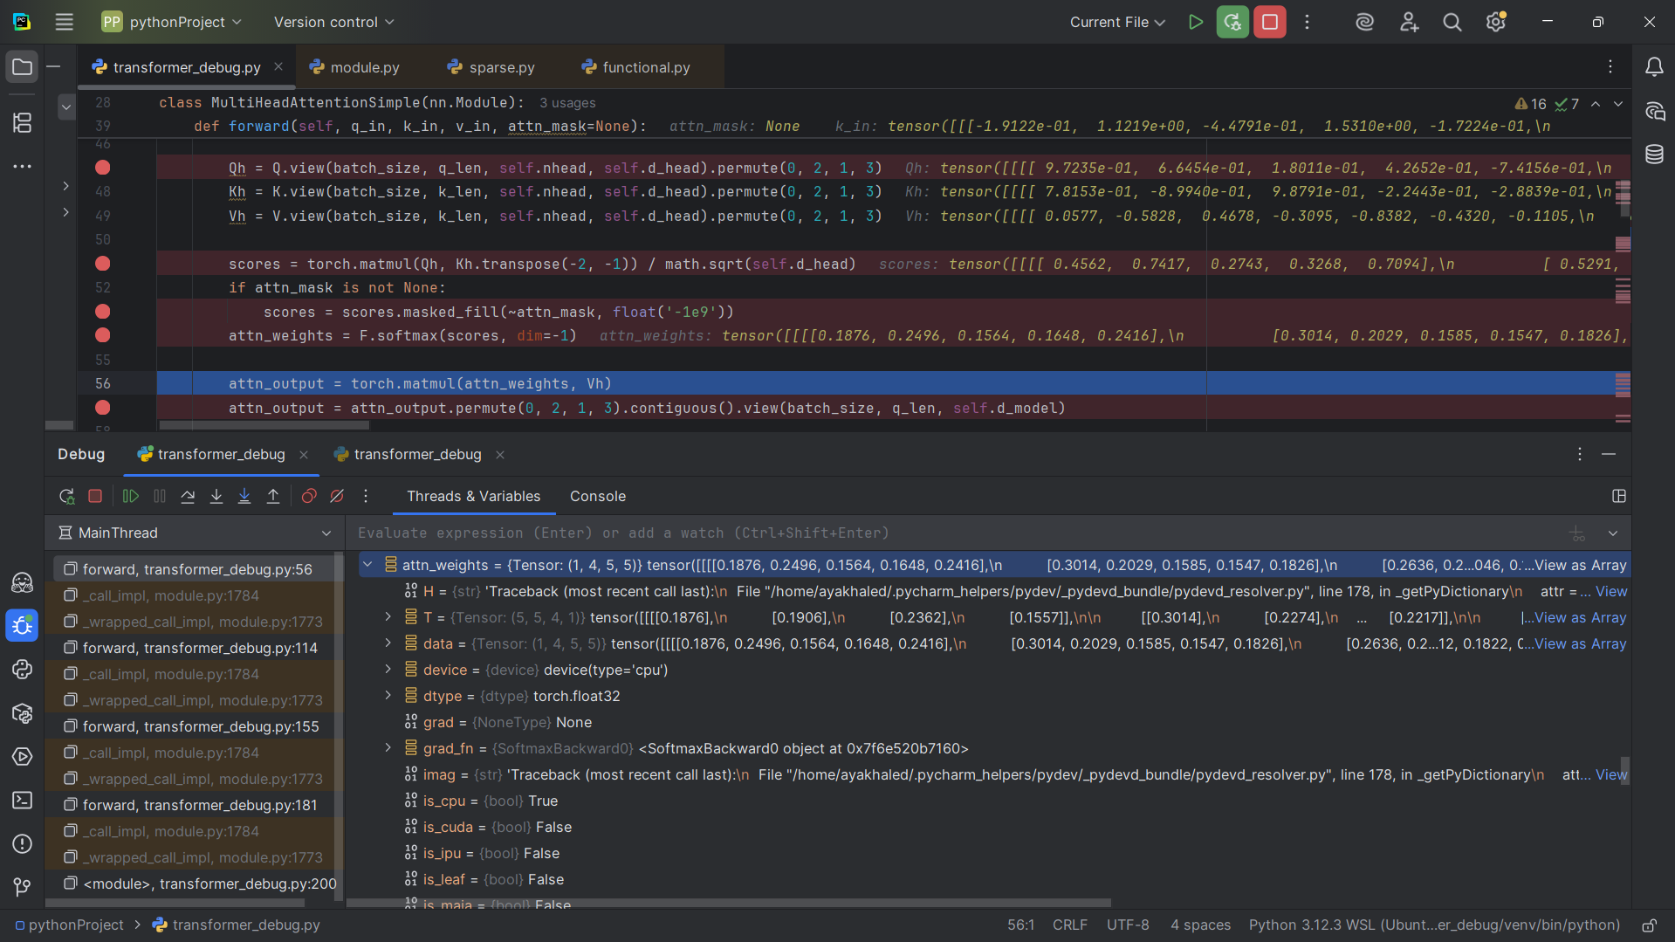

## Snapshot #35: Cross-attention output after concat

Shape: (1, 5, 128)

Sample values:[[1.0041e-03 , 7.7174e-02 , 5.7731e-01, . . . ] , [ -8.4463e-01 , 3.0630e-01 , . . .] [ . . . ] ]

Explanation: Multi-head results are concatenated to produce (batch, seq_len, d_model).

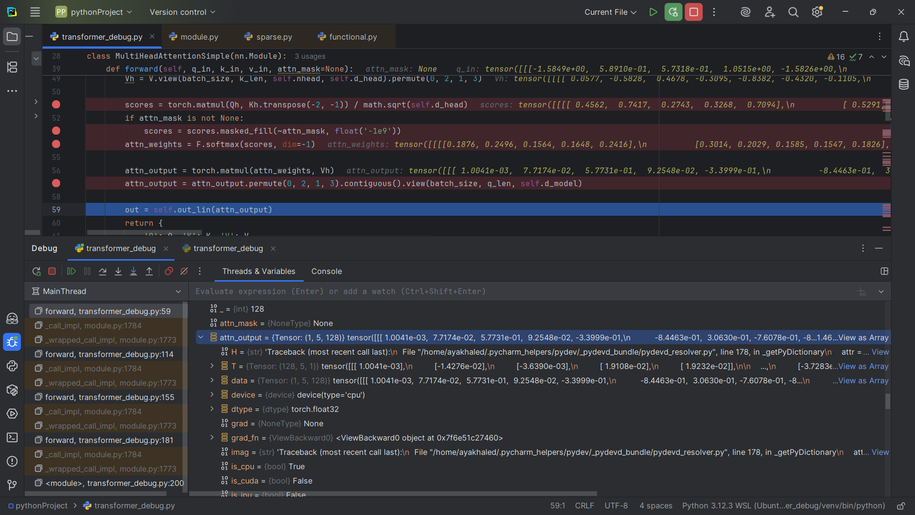

## Snapshot #36: Residual + LayerNorm after cross-attention

Shape: (1, 5, 128)

Sample values: [[-1.3008e+00 , 1.0976e+00 , 5.5689e-01, . . . ] [ -1.5926e-01 ,

-1.0006e+00 , . . . ] [ . . . ] ]

Explanation: Residual connection keeps input information, normalization stabilizes training.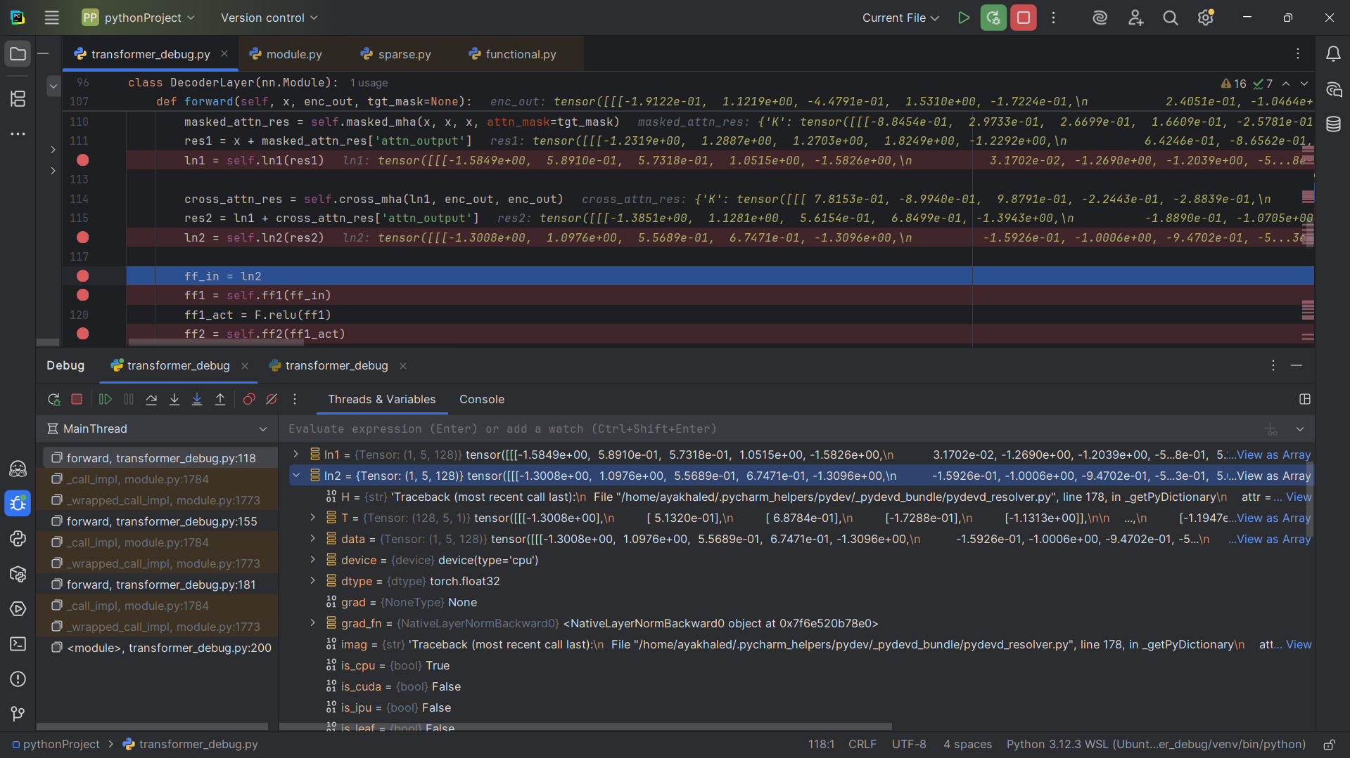

## Snapshot #37: Decoder feed-forward input

Shape: (1, 5, 128)

Sample values: [[-1.3008e+00 , 1.0976e+00 , 5.5689e-01 , . . . ], [ -1.5926e-01 ,

-1.00056e+00 , . . . ] [ . . . ]]

Explanation: The tensor passed into the feed-forward sublayer.

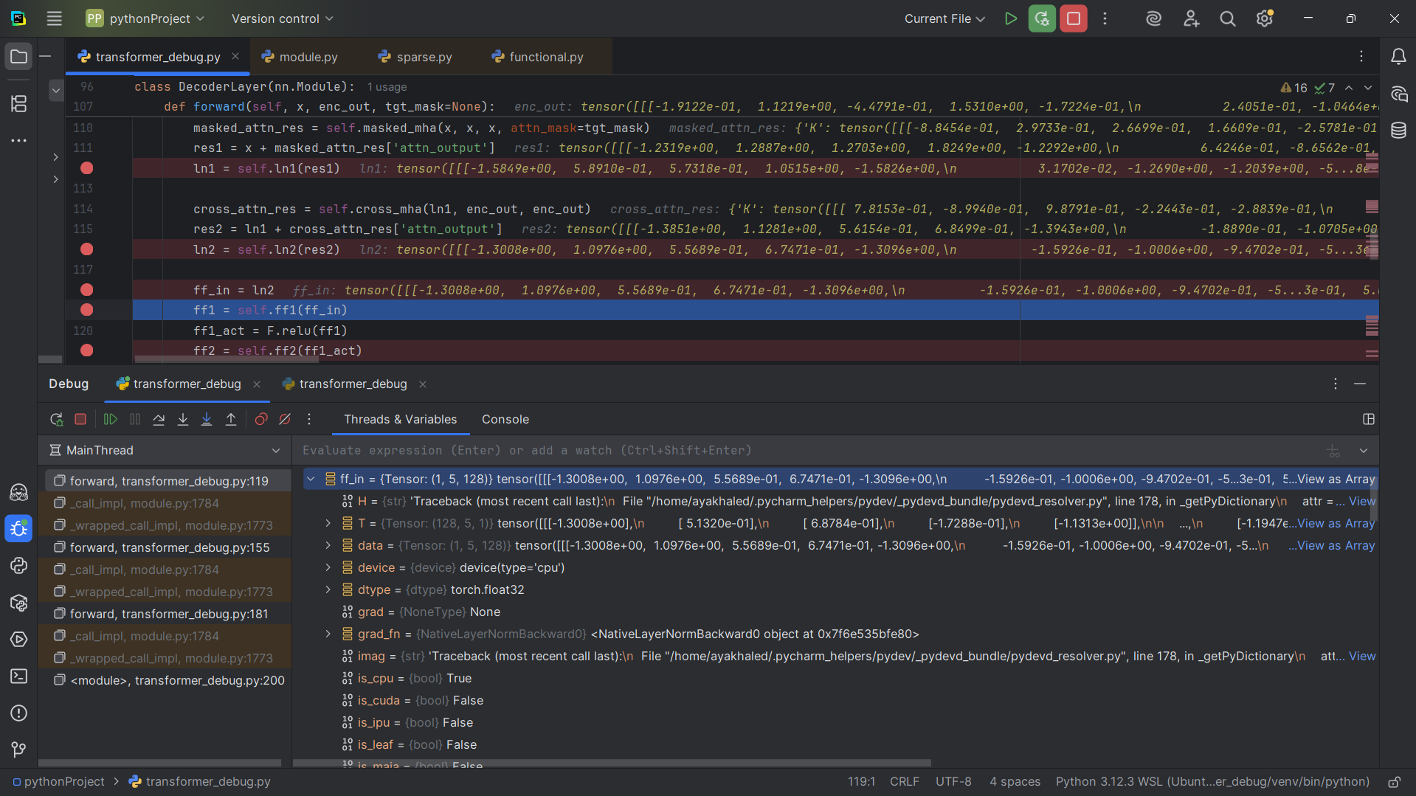

## Snapshot #38: Decoder FFN first linear (ff1)

Shape: (1, 5, 512)

Sample values: [[-0.5732 , -0.9821 , 0.0928 , . . .] [0.7712 , -0.1157 , . . . ] [ . . . ]]

Explanation: Expanded to (batch, seq_len, d_ff) with non-linearity applied.

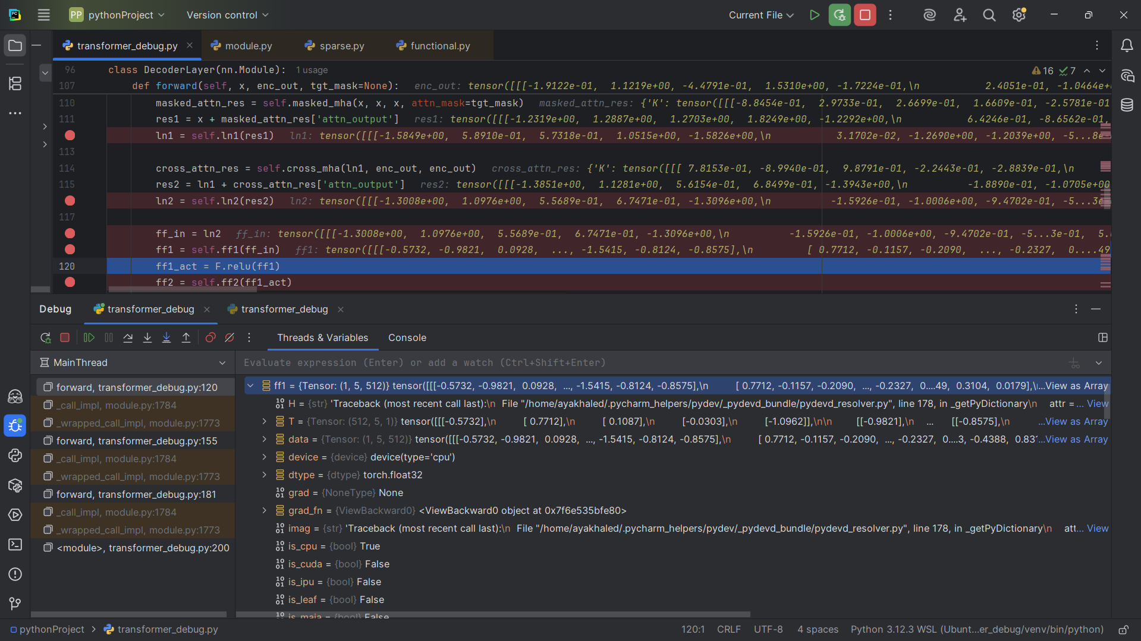

## Snapshot #39: Decoder FFN second linear (ff2)

Shape: (1, 5, 128)

Sample values: [[-1.5440e-01 , -2.2226e-01 , 1.8909e-01, . . . ] , [ -5.7362e-01 , 2.1714e-01, . . . ] [ . . . ]]

Explanation: Projected back to (batch, seq_len, d_model) to match the model dimension.

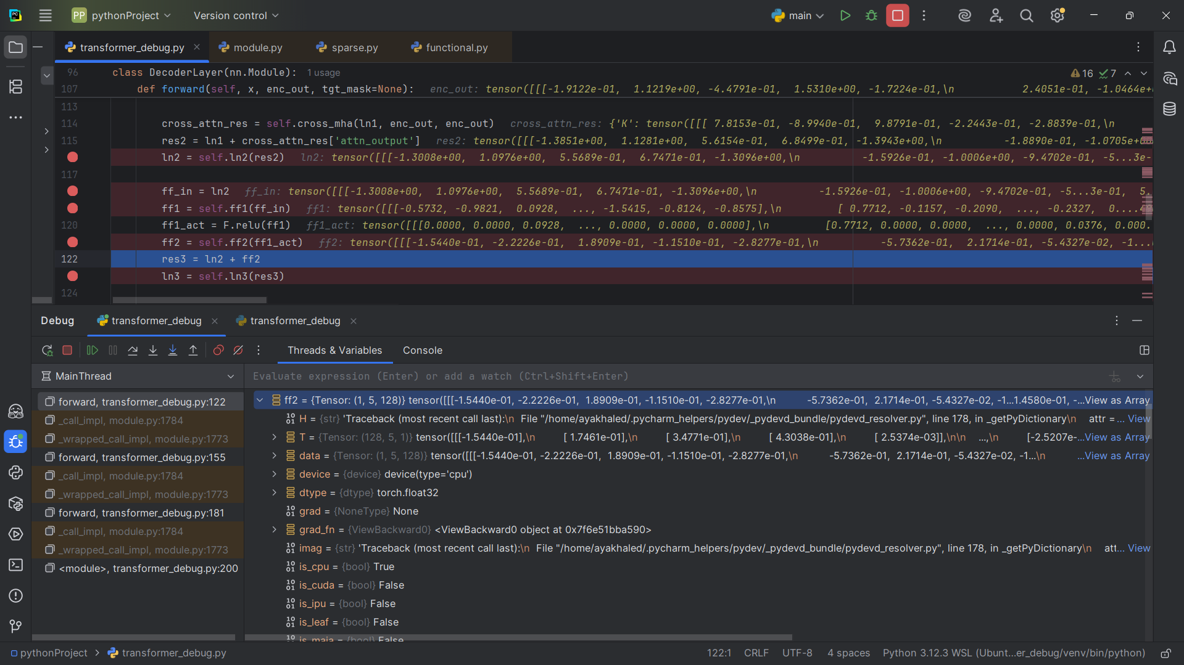

## Snapshot #40: Decoder block final output (ln3)

Shape: (1, 5, 128)

Sample values: [[-1.4038e+00 , 8.5738e-01 , 7.3188e-01, . . . ] , [-7.0298e-01 ,

-7.5203e-01 , . . . ] [. . . ]]

Explanation: The output after residual and normalization, ready for the next decoder layer or projection.

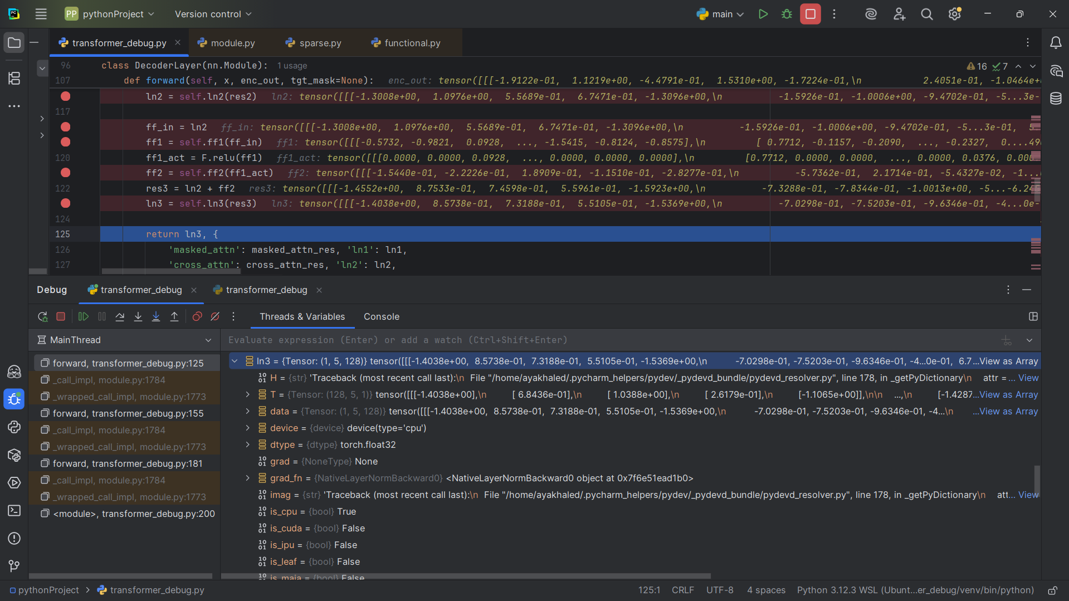

## Snapshot #41: Decoder final sequence output (before projection)

Shape: (1, 5, 128)

Sample values: [[-1.5437e+00 , 5.5214e-01, 1.4473e+00 , . . .] , [6.9425e-02 , -4.3633e-01, . . . ] [ . . . ]]

Explanation: Final hidden states of the decoder before projecting to the vocabulary.

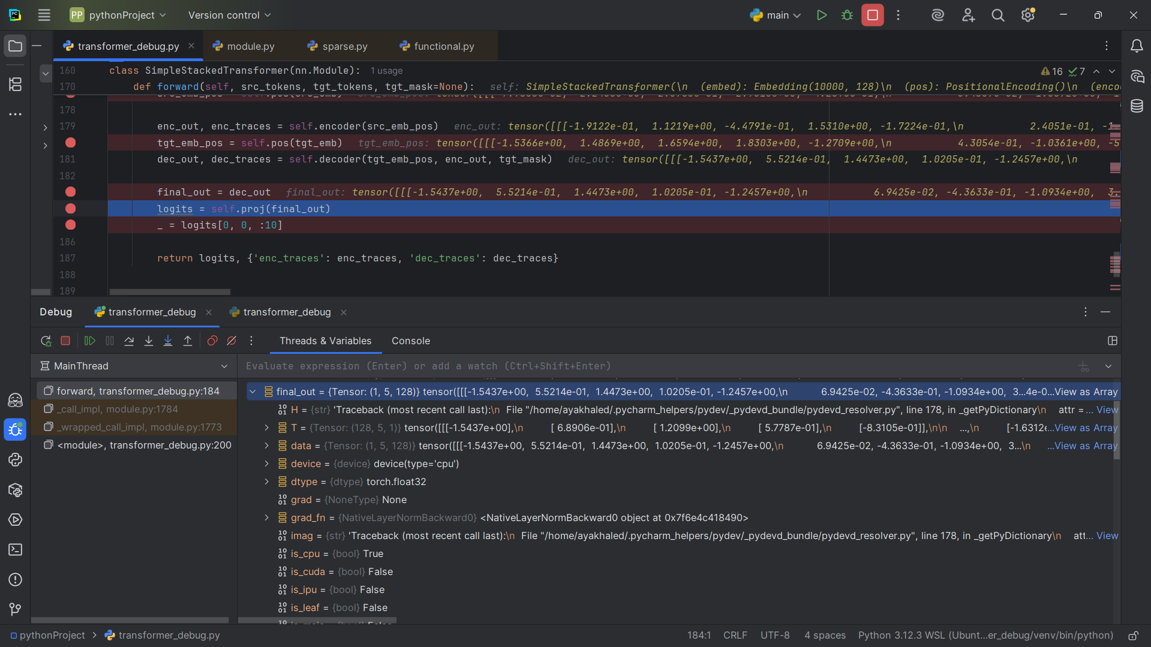

## Snapshot #42: Logits after final linear projection

Shape: (1, 5, 10000)

Sample values: [[1.0584 , 0.4644 , 0.1374 , . . . ] , [0.1994 , 0.3577 , -0.3098 , . . .] [ . . . ]]

Explanation: Each position is mapped to vocabulary logits (batch, seq_len, vocab_size).

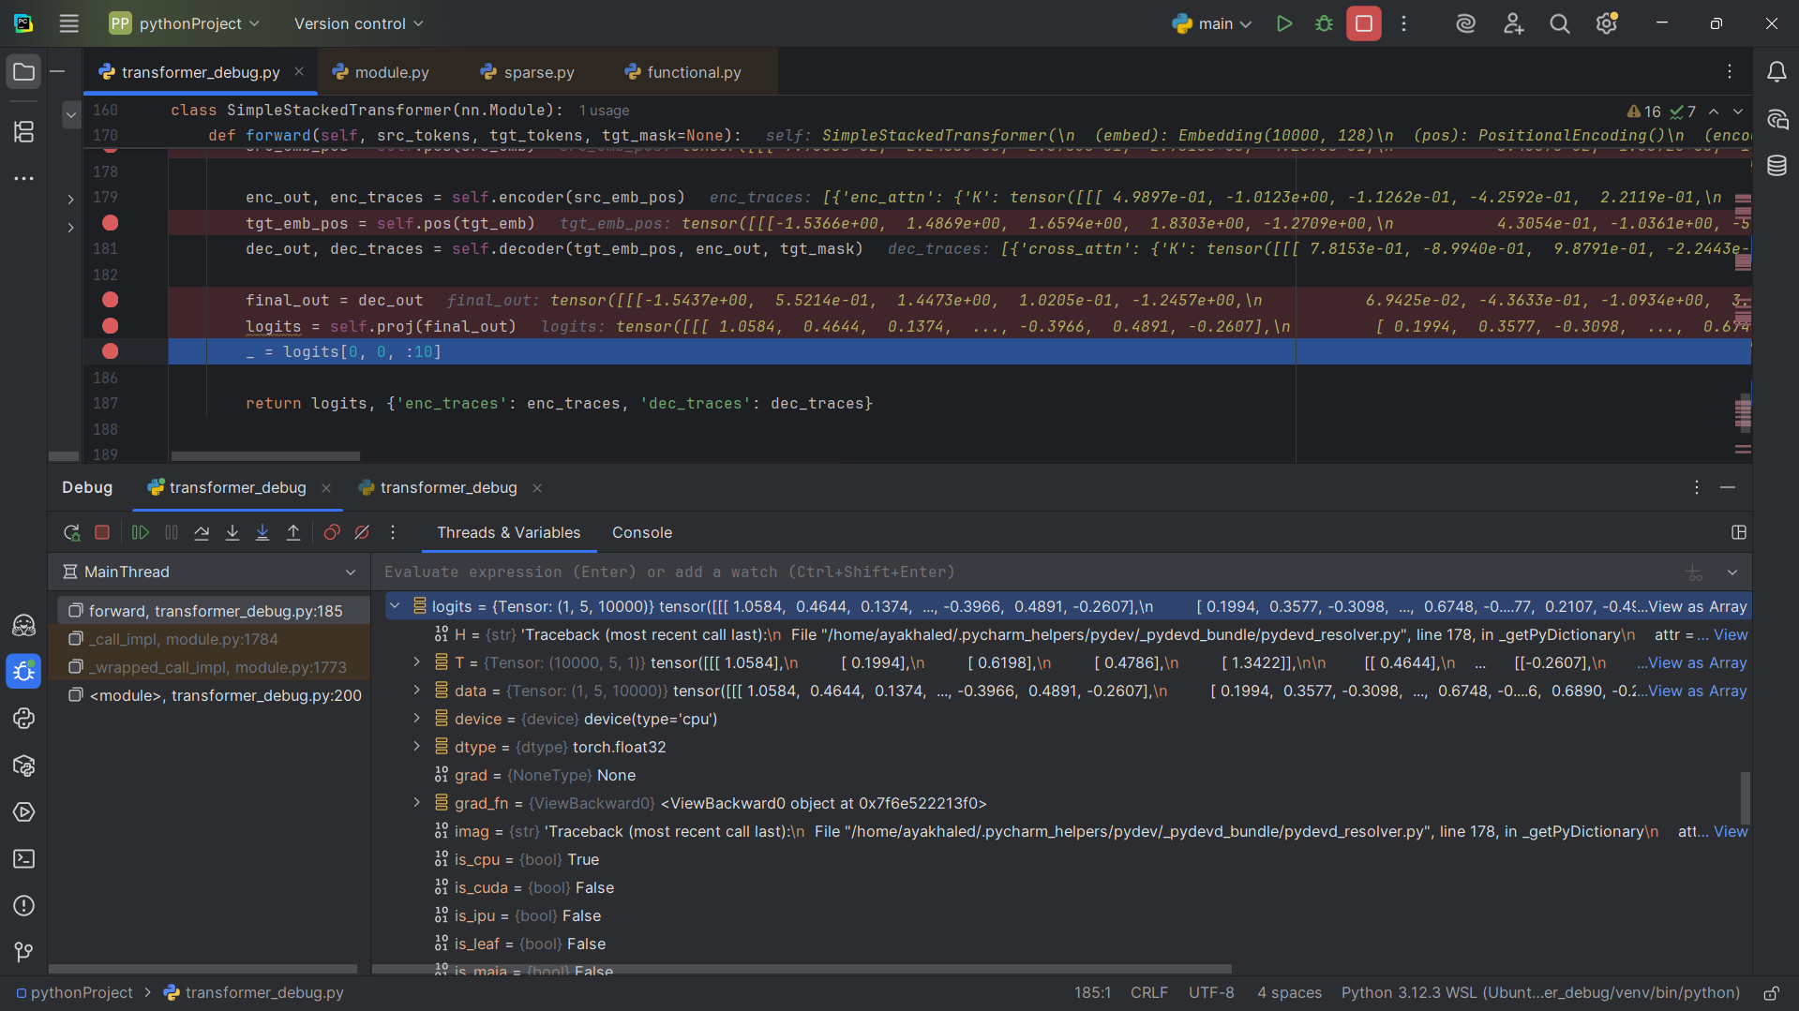

## Snapshot #43: Logits slice (first token, first 10 values)

Shape: (10,)

Sample values: [[1.0584 , 0.4644 , 0.1374 , . . . , 0.1836 , -0.1192 ]]

Explanation: A small slice of the logits showing predicted scores for a few vocabulary tokens.

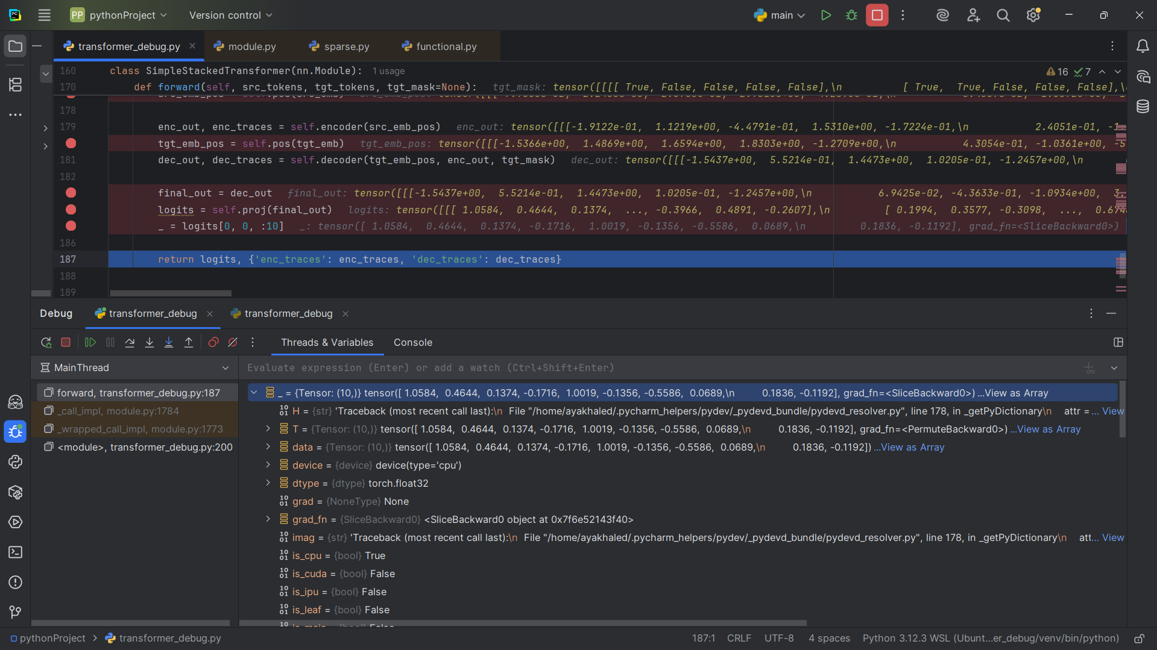

# Guiding Questions

Q1: What do each of the dimensions represent at embedding, attention, feed-forward, and output stages?  
A1: At embedding: (batch, seq_len, d_model). At attention: (batch, heads, seq_len, d_head). At feed-forward: (batch, seq_len, d_ff). At output: (batch, seq_len, vocab_size).

Q2: Why do Q, K, V tensors have the same shape, and why are they split into heads?  
A2: Q, K, V must align so dot products are valid. They are split into heads to capture different relations in parallel subspaces.

Q3: What do the attention score matrices represent, and why must they be square?  
A3: They show how much each token attends to every other token in the same sequence. They are square because every token compares against all tokens of equal length.

Q4: Why is masking necessary in the decoder, and how does the mask tensor enforce it?  
A4: Masking prevents access to future tokens during training. The triangular mask sets future positions to -inf, so softmax assigns them zero probability.

Q5: How do residual connections and layer normalization ensure consistency of shapes across blocks?  
A5: Residual connections add inputs and outputs of the same shape, ensuring stability. LayerNorm keeps distributions normalized and avoids exploding or vanishing values.

Q6: Why must the embedding dimension remain constant through all layers?  
A6: To ensure residuals and layer connections remain valid; otherwise, shapes would mismatch.

Q7: How does the final projection connect decoder output to vocabulary logits?  
A7: A linear layer projects from d_model to vocab_size, producing logits that represent scores for each vocabulary token.